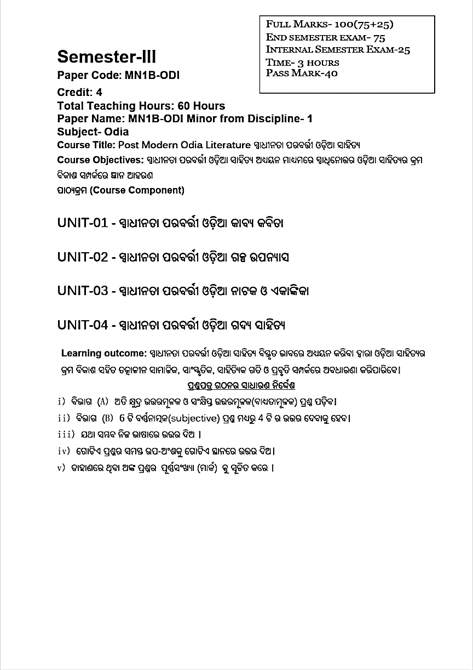

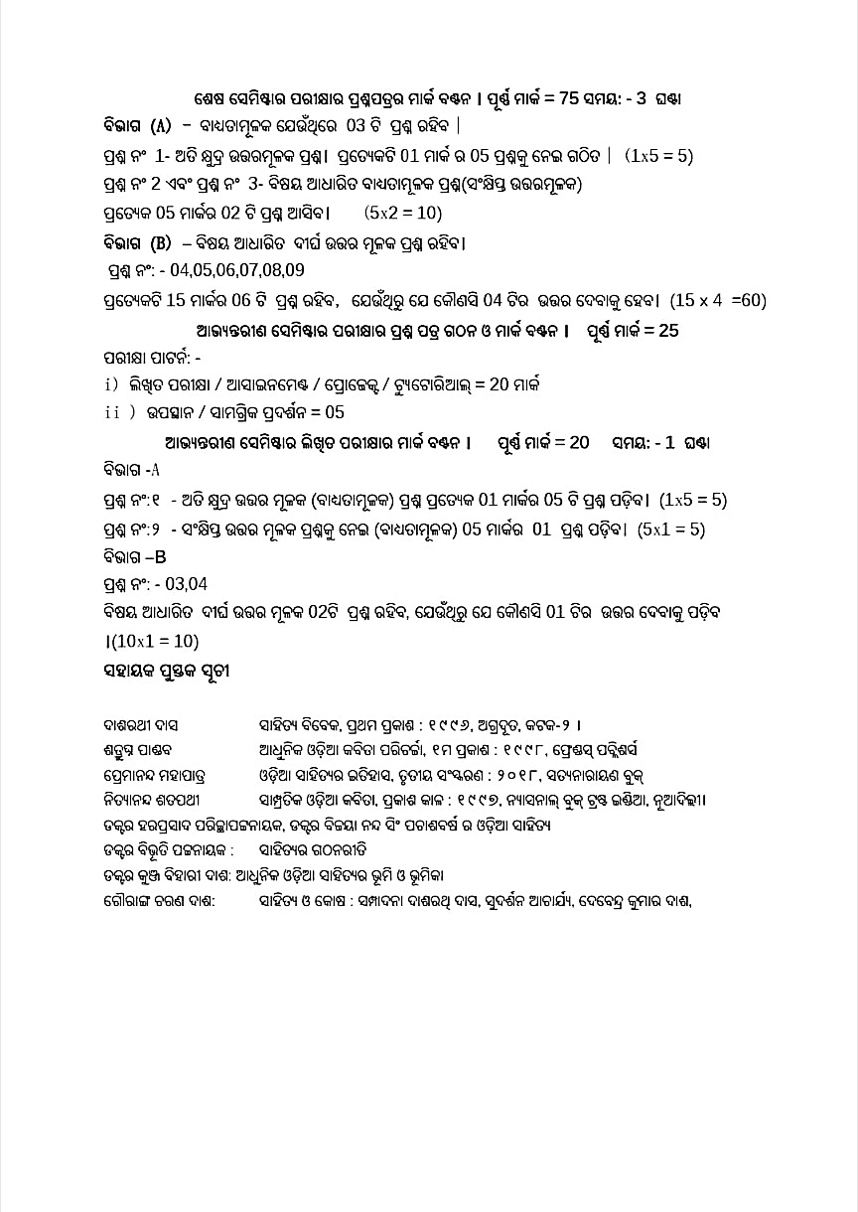

**NOTE:- ALL SYLLABUS MANAGED BY DR. ANUPAMA MISHRA**

**SYLLABUS AS PER FYUGP NEP-2020(W.E.F.-2024-2025)**

**U.G. SEM-1, SUB-M.D.C.-3**

**(ODIA)**

**(ODIA SAHITYARA SAMANYA PARICHAYA)**

**Full Marks-75( No Internal, TEE-75) Total Credit-03**

**Pass Marks-30 Total Lectures 45 (1 hour/ Per Lect.)**

**UNIT-1(15-Lectures)-**

**i) Keshaba Koili (Poem) - Markanda Das**

**ii) Mathura Mangala (Kavya) - Bhakta Charan Das**

**UNIT-2 (15-Lectures)-**

**i) Chatura Binoda- Brajanath Badjena**

**ii) Kishor Chandranan Champu (Ga Champu)- Baldeva Ratha**

**UNIT-3 (15-Lectures)-**

**i) Dak Munsi (Story)- F.M. Senapati**

**ii) Sandhya Asarara Bhuta (Ekankika)- Prana Bandhu Kara**

**iii) Chaibasa (Poem)- Sachidanand Rout Roy**

**Marks distribution and question Pattern-**

|  |  |  |  |
| --- | --- | --- | --- |
| **Section** | **Particulars** | **Marks** |  |
| **A** | **Total five questions of objective type answers/ mcq of one marks each** | **5 x 1 = 5** | **Total Marks = 75** |
| **A-1** | **Total four question of short answer type to answer any 2 of 5 marks each** | **2 x 5 = 10** |  |
| **B** | **Total six questions, long answer type,answer any four of 15 marks each** | **4 x 15 = 60** |  |

**NOTE:- ALL SYLLABUS MANAGED BY DR. ANUPAMA MISHRA**