## DEPARTMENT OF

**ODIA**

## ANNUAL REPORT 2022-23

**Department of Odia**

The Department of Odia has been a cornerstone of our institution since its inception in 1961. It stands as one of the oldest departments, dedicated to promoting the study and appreciation of Odia language and literature. The department offers MDC (Master of Arts in Odia) and General courses, tailored to meet the educational needs of our diverse student body.

Our faculty includes dedicated professionals, led by a full-time Assistant Professor, who guides students through a curriculum designed to explore the rich tapestry of Odia literature and language. Regular assessments, including class tests every three months, ensure thorough preparation for final examinations.

Graduates of the Department of Odia have achieved notable success in various fields, including education, journalism, and cultural advocacy, both regionally and nationally. The department takes pride in nurturing students and preparing them for meaningful contributions to society.

**Department Profile**

|  |  |
| --- | --- |
| Establishment Year : | 1961 |
| Previous Faculty Members : | Mr. Kailash Pradhan  Mrs. Nandika Mohanty |
| Present Faculty Members : | Dr. Anupama Mishra |

**Syllabus Distribution**

**During**

## 2022-23

**SYLLABUS AS PER FYUGP NEP-2020(W.E.F.-2022-2023)**

**U.G. SEM-1, SUB-ODIA MINOR (MN-01)**

**(ODIA)**

**(ODISHA O ODIA SAHITYARA SANSKRUTIKA BIKASHA DHARA)**

**Full Marks-100( Mid Term - 25, End Term -75) Total Credit-04**

**Pass Marks-40**

**UNITS-**

**1- Odishara Sanskrutika Bikashdhara**

**2- Odia Sahityara Sankshipta Itihasa**

**A) Prak Sarala O Sarala Yuga**

**B) Panchasakha Yuga**

**C) Purba O Uttara Madhya Reeti Yuga**

**D) Adhunika O Uttara Adhunika Yuga**

**3- Adhunika OdiaGadya O Padya Sahitya**

**4- Swadhinata Paravarti Odia Sahityara Bisheshatwa**

**SUGGESTED READINGS-**

**1- Odishara Sanskrutika Itihasa-Sanskruti Bibhaga, Odisha**

**2- Odia Sahityara Samajika O Sanskrutika Itihasa-Chittaranjan Das**

**3- Odia Sahityara Adiparva - Surendra Mohanty**

**4- Odia Sahityara Sankshipta Parichaya-Brundabana Acharya**

**5- Odia Gadya Sahitya- Srinivas Mishra**

**6- Odia Sahityara Itihasa-Natabara Samanta Ray**

**7- Sabujaru Sampratika-Nityananda Satpathy**

**Marks distribution and question Pattern-**

|  |  |  |  |
| --- | --- | --- | --- |
| **Section** | **Particulars** | **Marks** |  |
| **A-I** | **Q.no.1 Will contain 05 objective type questions (MCQ/True-False/Fill in the blank etc.) for one mark each** | **5 x 1 = 5** | **Total Marks = 75** |
| **A-1** | **Q.no. 2 &3 will be short answer type of 5 marks** | **2 x 5 = 10** |  |
| **B** | **6 question of descriptive type, of which 4 have to be answered for 15 marks each** | **4 x 15 = 60** |  |

**NOTE:- ALL SYLLABUS MANAGED BY DR. ANUPAMA MISHRA**

**SYLLABUS AS PER FYUGP NEP-2020(W.E.F.-2022-2023)**

**U.G. SEM-1, SUB-M.D.C.-**

**(ODIA)**

**(ODIA SAHITYARA SAMANYA PARICHAYA)**

**Full Marks-75( No Internal, TEE-75) Total Credit-03**

**Pass Marks-30 Total Lectures 45 (1 hour/ Per Lect.)**

**UNIT-1(15-Lectures)-**

**i) Keshaba Koili (Poem) - Markanda Das**

**ii) Mathura Mangala (Kavya) - Bhakta Charan Das**

**UNIT-2 (15-Lectures)-**

**i) Chatura Binoda- Brajanath Badjena**

**ii) Kishor Chandranan Champu (Ga Champu)- Baldeva Ratha**

**UNIT-3 (15-Lectures)-**

**i) Dak Munsi (Story)- F.M. Senapati**

**ii) Sandhya Asarara Bhuta (Ekankika)- Prana Bandhu Kara**

**iii) Chaibasa (Poem)- Sachidanand Rout Roy**

**Marks distribution and question Pattern-**

|  |  |  |  |
| --- | --- | --- | --- |
| **Section** | **Particulars** | **Marks** |  |
| **A** | **Total five questions of objective type answers/ mcq of one marks each** | **5 x 1 = 5** | **Total Marks = 75** |
| **A-1** | **Total four question of short answer type to answer any 2 of 5 marks each** | **2 x 5 = 10** |  |
| **B** | **Total six questions, long answer type,answer any four of 15 marks each** | **4 x 15 = 60** |  |

**NOTE:- ALL SYLLABUS MANAGED BY DR. ANUPAMA MISHRA**

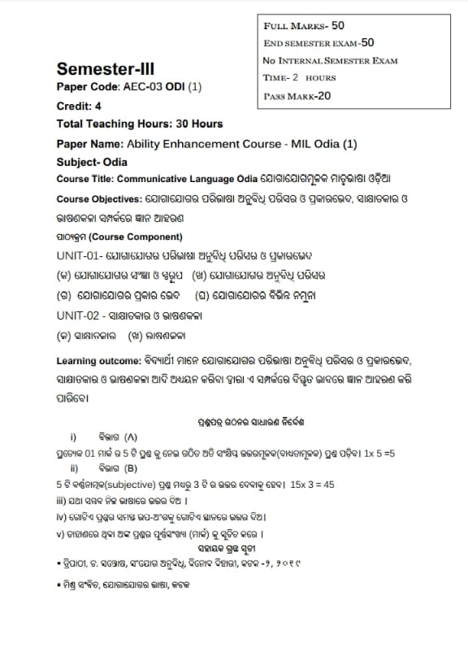

## DEPARTMENTAL

**ROUTINE**

**DURING**

**2022-23**

**DEPARTMENTAL ROUTINE DEPARTMENT OF ODIA- SESSION – 2022-23**

**MINOR, MDC and SEC-IV 2022-2023**

|  |  |  |  |  |  |  |  |
| --- | --- | --- | --- | --- | --- | --- | --- |
|  | **11:00 – 12:00** | **12:00 – 1:00** | **1:00 – 2:00** | **2:00 – 3:00** | **3:00 – 4:00** | **4:00 – 5:00** | **5:00 – 6:00** |
| **Monday** | - | - | MDC -II | - | SEM – I  (MDC – I) | - | - |
| **Tuesday** | MDC - II | - | SEM – I  (MDC – I) | MN - IA | - | SEM – VI  (SEC - IV) | SEM – II  MN – IIA |
| **Wednesday** | - | - | MN - IA | - | - | - | - |
| **Thursday** | - | SEM – II  MN – IIA | - | - | MN - IA | SEM – VI  (SEC - IV) | - |
| **Friday** | - | - | - | - | - | - | SEM – I  MN – IA |
| **Saturday** | - | MDC - II | MN - IA | SEM – II  MN - IIA | - | SEM – I  (MDC – I) | - |

All classes are managed by Dr. Anupama Mishra

# RESULTS

# 2022-23

**RESULTS**

**Internal Results of Minor - IIA**

|  |  |  |
| --- | --- | --- |
| SL. NO. | NAME | MARKS |
| 1. | Smaran Raika | 20 out of 25 |
| 2. | Krishna Giri | 19 out of 25 |

**ACADEMIC PROGRESS**

**OF**

**DEPARTMENTAL**

**PROFESSORS**

**DURING 2022-23**

**Dr. Anupama Mishra**

Assistant Professor, Dept. of Odia Karim City College, Jamshedpur

1. **Paper Presented in National Conference on 7th to 8th July 2023 organised by Netaji Subhas University Jamshedpur.**

**Topic : "Sustainability and Women"**

1. **Attended Faculty Induction Programme (Aligarh Muslim University, Aligarh)**

**From 08-09-2023 To 13-10-2023**

1. **Research Papers in Journals: Article Published in Vol. C-IV, issue 7th July 2023, Annals of the Bhandarkar oriental research institute with IFSN: 0378-1143, UGC CARE list group-I, Impact factors 6.5 (Titled - Sustainability & Women)**

## Department of Odia

## Vision & Mission

## of

## 2022-23

**Vision :**

1. To equip students with effective learning strategies for skill development.
2. To enhance language proficiency for practical application in diverse contexts.
3. To foster a deep appreciation for Odia literature, enriching students' understanding of moral and intellectual aspects of human life.
4. To provide updated knowledge and comprehensive insights into world literature.

**Mission :**

1. To emphasize the practical utility of language comprehension and the cultural significance of Odia literature.
2. To promote language and literature as essential expressions of human creativity and cultural heritage.

**New Courses Development Plan (If any)**

**–** Skill development course

–Translation and transcreation course