**KARIM CITY COLLEGE, JAMSHEDPUR**

ACTIVITIES 2024-25

**Centre for Guidance & Counselling**

**Name of The Activity / Event : -** Counselling Camp

**Date & Time : -** 10-12-2024

**Mode of the Activity / Event : -** In - Person

**Nature of the Events : -**  Academic

**Venue : -** BBA Department **,** Karim City College

**Chief Guest & Other Guests : -** Dr. Mohammad Reyaz **(**Principal)

**Numbers of Participants / Performers : -** 40

**Approx Number of Audience : -** 60

**Announcement of the Activity / Event : -**

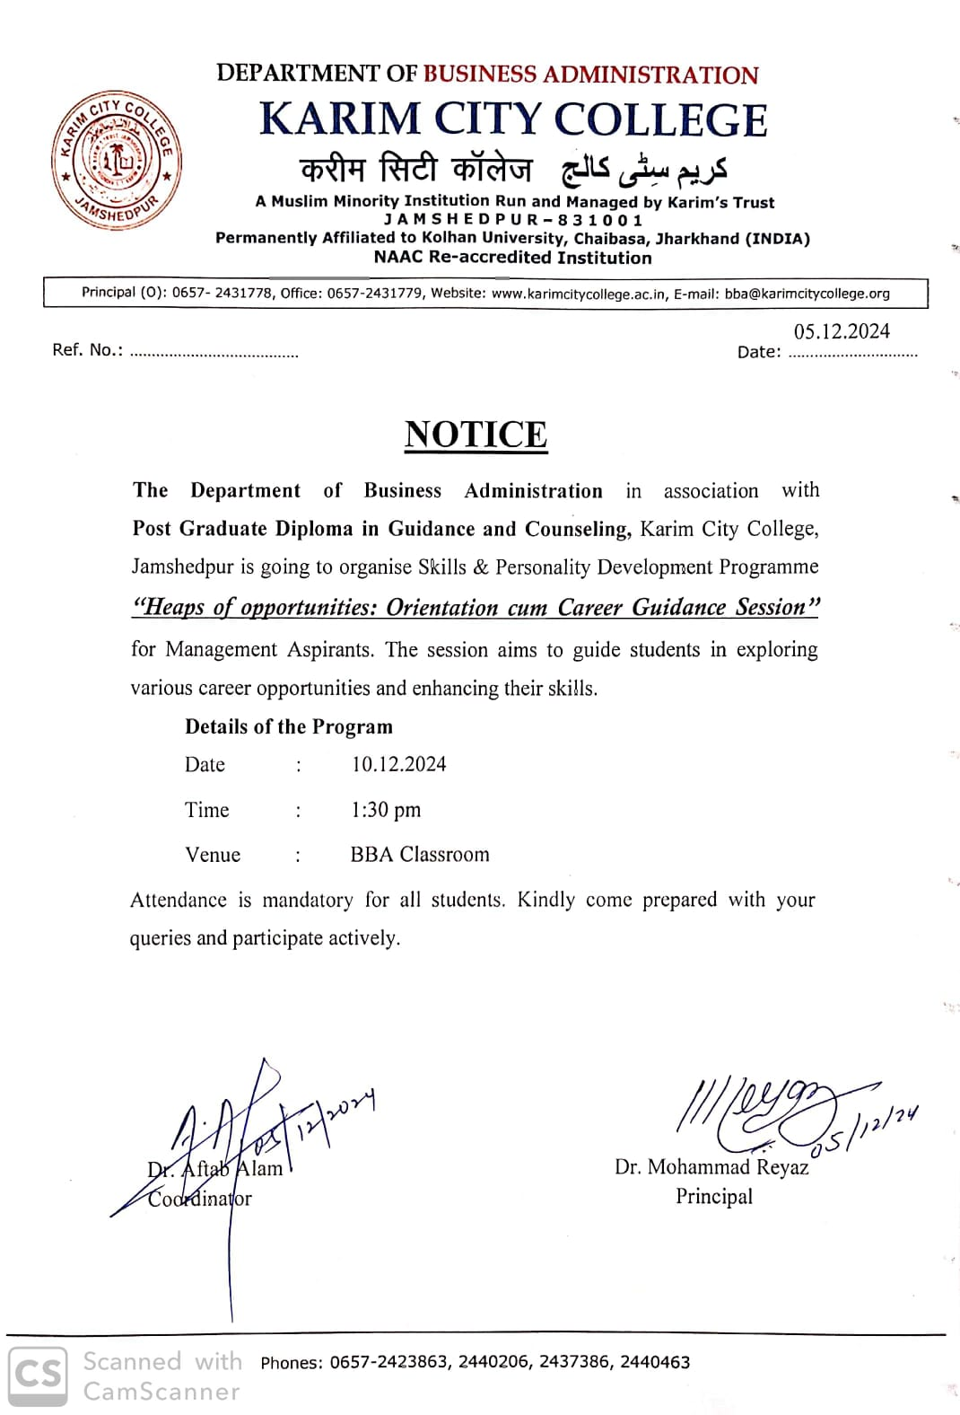

**Detailed Description : -**

The Counselling Camp was organized by the Centre for Guidance and Counselling at Karim City College to assess the level of stress and mental health of BBA students. The initiative aimed to provide psychological support, identify key stressors, and offer coping strategies to enhance students' well-being.

**Event Photographs : -**

|  |  |
| --- | --- |
|  |  |

**News Clippings : -**

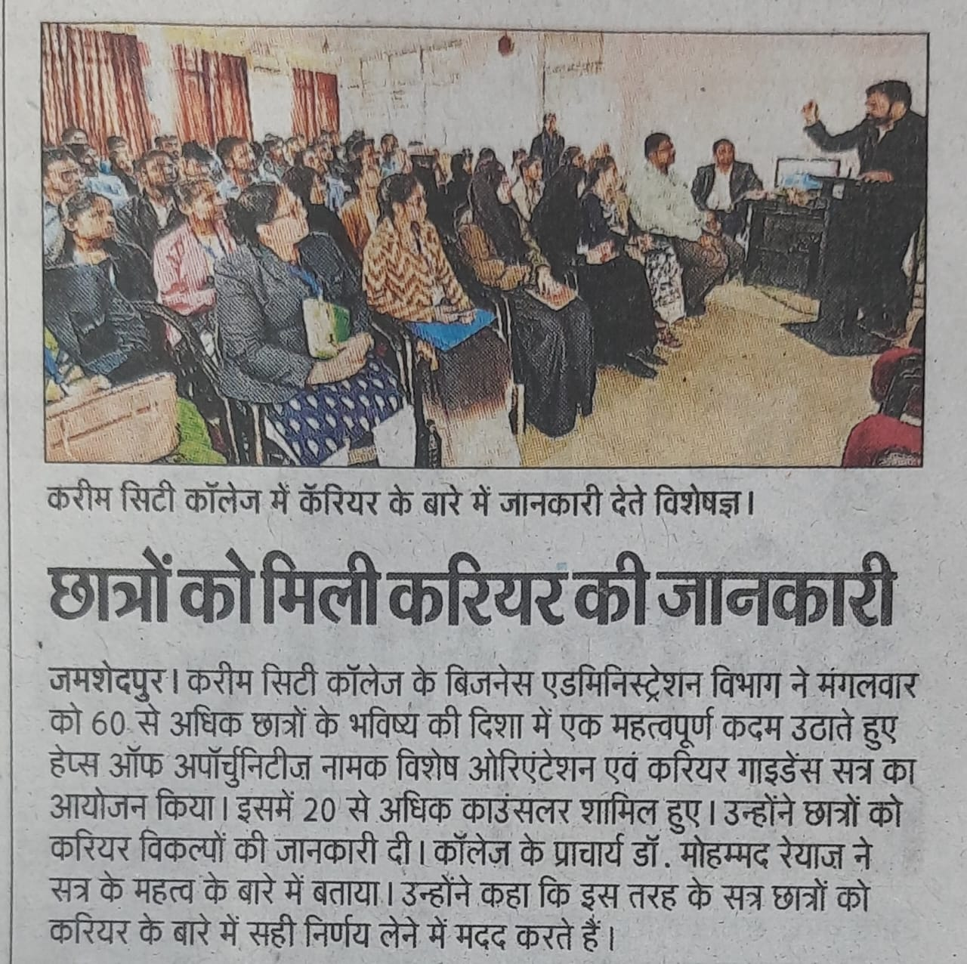

**Outcomes : -**

The Counselling Camp organized by the Centre for Guidance and Counselling at Karim City College successfully assessed the stress levels and mental health conditions of BBB students. The key outcomes of the camp were:

1. Identification of Stress Factors – Common academic, personal, and social stressors affecting students were identified.

2. Mental Health Awareness – Students gained insights into the importance of mental well-being and the impact of stress on their daily lives.

3. Personalized Counselling – Many students received one-on-one counselling sessions to discuss their concerns and challenges.

4. Coping Strategies – Practical techniques such as mindfulness, time management, and relaxation exercises were introduced to help students manage stress effectively.

5. Referral for Further Support – Students requiring extended psychological support were guided toward professional counselling and intervention.

6. Positive Student Feedback – Participants appreciated the initiative, reporting a better understanding of their mental health and a more confident approach to handling stress.