**KARIM CITY COLLEGE, JAMSHEDPUR**

ACTIVITIES 2024-25

**Centre for Guidance & Counselling**

**Name of The Activity / Event : -** One Day Orientation Visit at RINPAS, Ranchi

**Date & Time : -** 11-01-2025

**Mode of the Activity / Event : -** In - Person

**Nature of the Events : -**  Academic

**Venue : -** RINPAS, Ranchi, Jharkhand

**Chief Guest & Other Guests : -** NA

**Numbers of Participants / Performers : - 45**

**Approx Number of Audience : -** 50

**Announcement of the Activity / Event : -**

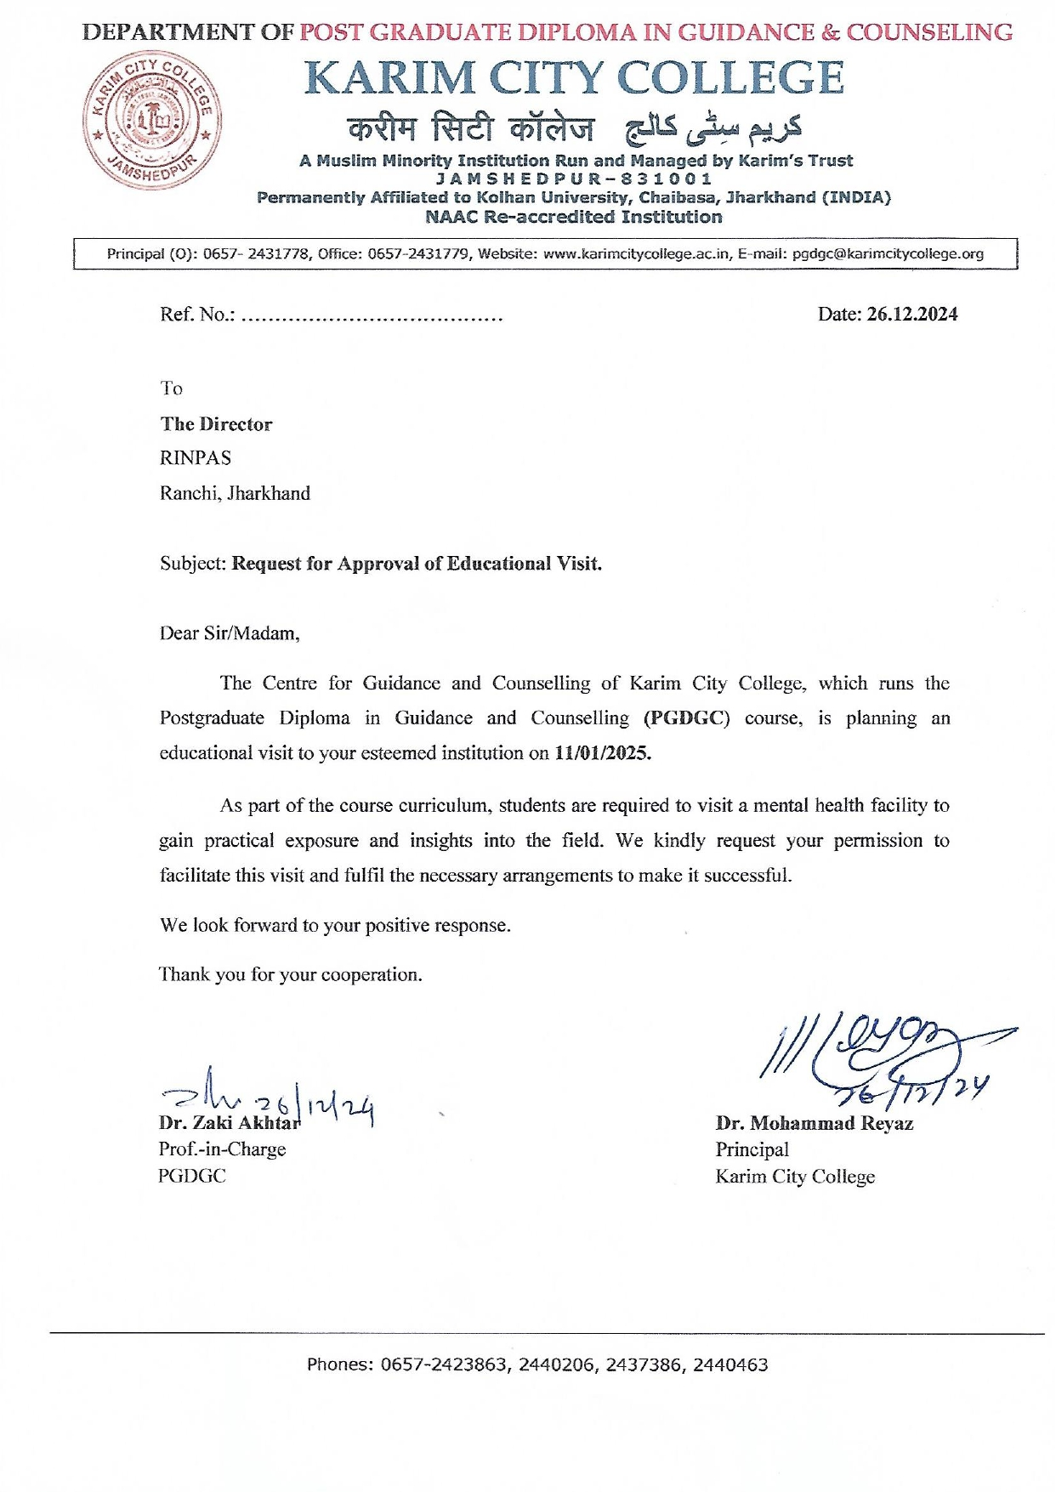

**Detailed Description : -**

On January 11, 2025, the PG students of the Department of Guidance and Counselling (PGDGC) at Karim City College, Jamshedpur, participated in a one-day orientation visit to the Ranchi Institute of Neuro-Psychiatry & Allied Sciences (RINPAS), Ranchi. The visit was aimed at providing students with practical exposure to psychiatric disorders, therapeutic interventions, and the functioning of a mental health institution.

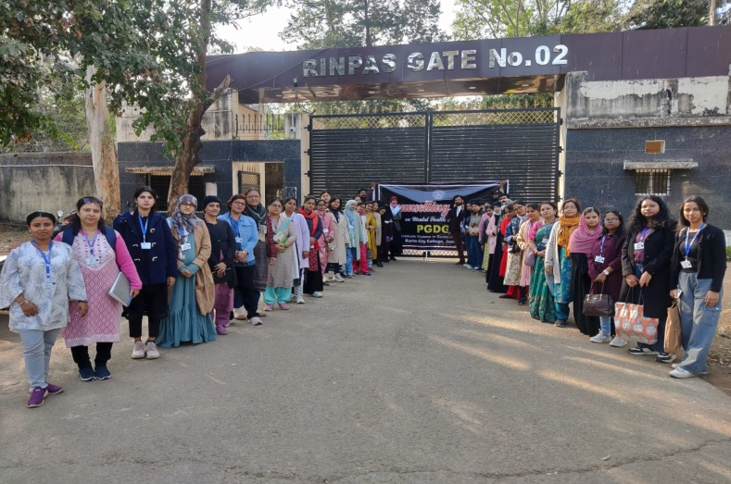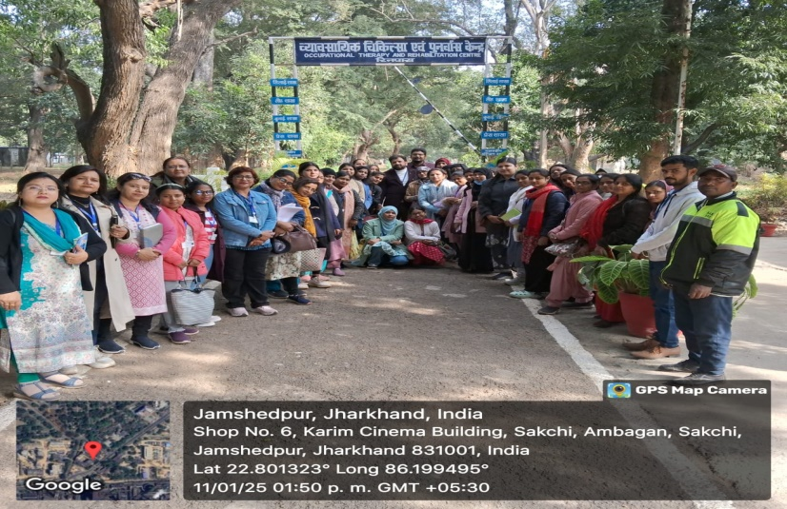**Event Photographs : -**

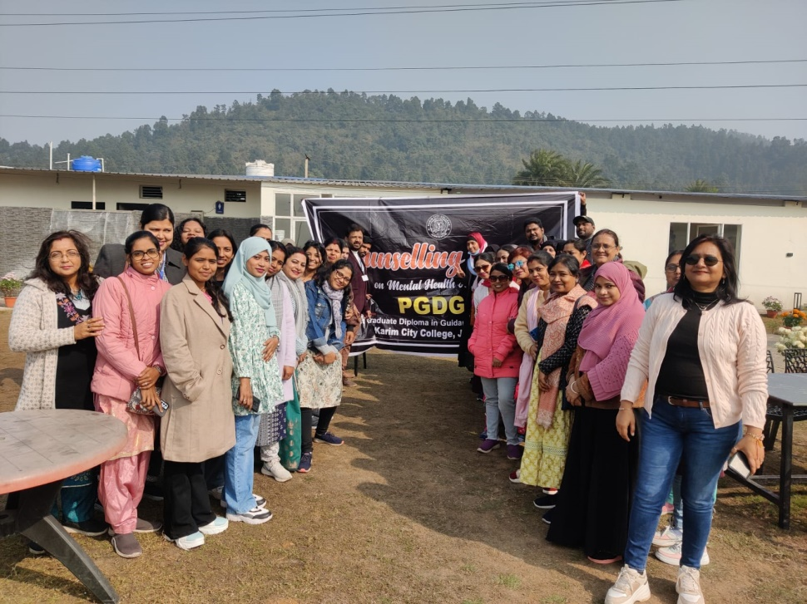

**News Clippings : -**

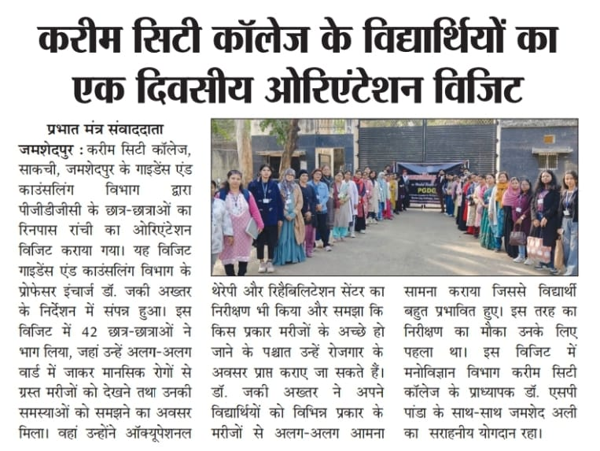

**Outcomes : -**

1. Introduction to RINPAS:

The visit commenced with a briefing session by RINPAS faculty, who provided an overview of the institution’s history, mission, and facilities. Students learned about different psychiatric disorders and the importance of mental health care in society.

2. Clinical Exposure:

The students observed various wards catering to different categories of patients, including acute psychiatric cases, chronic mental illnesses, and substance abuse cases. Experts explained the diagnostic process, medication management, and psychotherapy approaches for different mental disorders.

3. Interaction with Mental Health Professionals:

The students had interactive sessions with psychiatrists, clinical psychologists, and social workers who elaborated on their roles in patient management. Discussions included challenges in mental health care and strategies for counseling patients.

4. Rehabilitation and Therapy Observations:

The team visited the occupational therapy and rehabilitation units, where patients were engaged in activities like art therapy, vocational training, and social skills development. The role of counseling in reintegrating patients into society was emphasized.

The visit provided an in-depth understanding of the mental health care system. Students gained firsthand exposure to clinical and counseling settings. It reinforced the importance of empathy, patience, and ethical considerations in handling individuals with mental health concerns.