EVENT REPORT
KARIM CITY COLLEGE, JAMSHEDPUR
ACTIVITIES 2024-25
ROTARACT CLUB OF KARIM CITY COLLEGE

- Name of the event: National Doctor’s Day
Date and time: 01st July 2024
Mode of activity: In person
Nature of activity: Community Services
Venue: Jamshedpur Blood Bank
Guest:Dr. Anjani Bhushan Kumar
Number of Participants: 4participants
Number of audiences: 7
Announcement of activity:26th June 2024
Detailed Description:The Rotaract Club of Karim City Collegesuccessfully kicked off its new year by honouring Dr. Anjani Bhushan Kumar on National Doctors’ Day. Club President Md Shahid Raza presented the esteemed doctor with an appreciation letter for his exceptional contributions to the medical field.
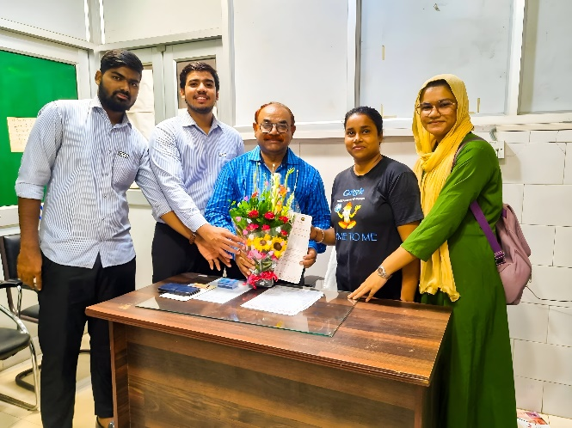
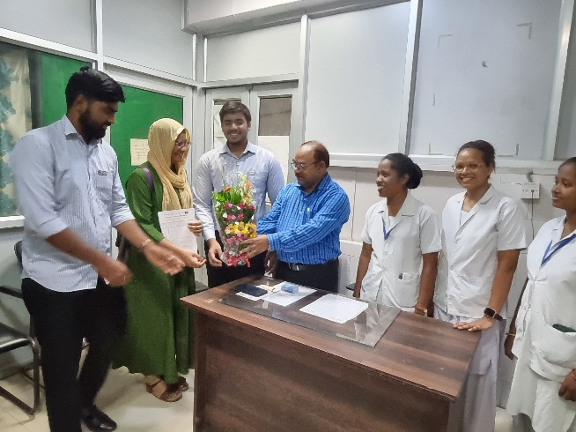
Event Photographs:

Outcomes:The outcomes of honouring Dr. Anjani Bhushan Kumar on National Doctors’ Day could include:
- Recognition & Motivation – The event highlighted the doctor’s contributions, boosting his morale and inspiring others in the medical field.
- Club Engagement – Strengthened the Rotaract Club’s reputation as an active, socially responsible organization.
- Awareness & Inspiration – Attendees and the community gained appreciation for doctors’ efforts, fostering respect for healthcare professionals.
- Networking Opportunities – Potential collaborations with medical professionals for future health initiatives.
- Member Participation – Increased enthusiasm among club members for organizing meaningful events.
Overall, it reinforced community ties and celebrated service excellence.

- Name of the event: Celebration of New Rota Year 2024-25
Date and time: 01st July 2024
Mode of activity: In-person
Nature of activity: Club Services
Venue: Dorabji Tata Park
Guest: N/A
Number of Participants: 2
Number of audiences: 20
Announcement of activity: 30th June 2024
Detailed Description: Rotaract Club of Karim City College joined forces with several other Rotaract clubs to mark the beginning of the new Rota year 2024-25. The celebratory event was hosted by the Rotaract Club of Steel City. The gathering provided an opportunity for Rotaractors from different clubs to connect, exchange ideas, and set the tone for a productive year ahead.
The event concluded with a celebratory note, marking a positive start to the new Rota year.
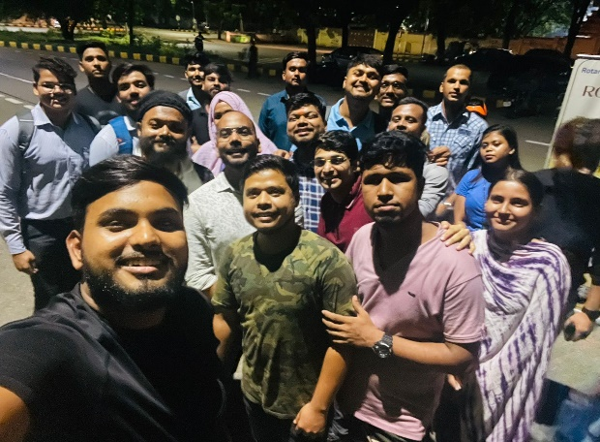
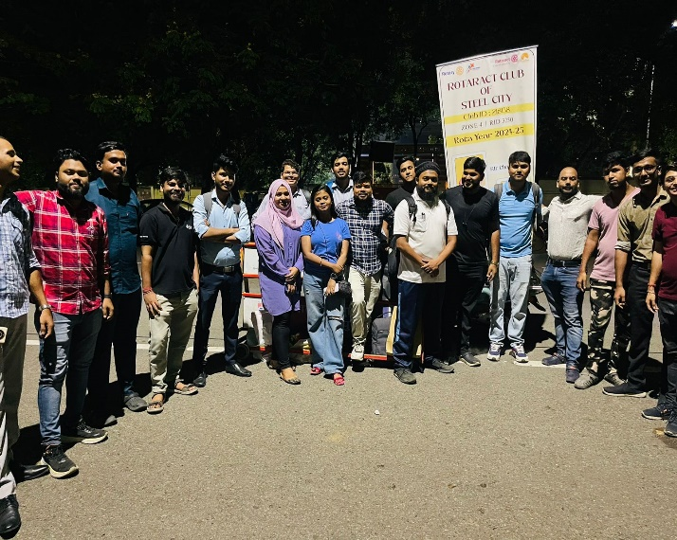
Event Photographs:

Outcomes:
- Strengthened Inter-Club Bonds – The partnership fostered unity and camaraderie among Rotaractors from different clubs, encouraging future collaborations.
- Shared Vision & Motivation – Members aligned on goals for 2024-25, gaining inspiration and fresh ideas for impactful projects.
- Networking & Learning – Rotaractors expanded their professional/social networks and exchanged best practices for club management and service initiatives.
- Increased Visibility – The event highlighted the clubs’ collective commitment to service, attracting potential members or sponsors.
- Positive Momentum – The energetic kick-off set an optimistic tone, boosting member engagement for upcoming activities.
Overall, it reinforced teamwork and purpose for the new Rota year!

- Name of the event: Fellowship Meet
Date and time: 6th July 2024
Mode of activity: In-person
Nature of activity: Club Services
Venue: D.B.M.S English College of Education
Guest: DRR Rtr. Rinku Kumar, DRS Rtr. Moushika Singha and other District delegates
Number of Participants: 2
Number of audiences: 30
Announcement of activity: 3rd July 2024
Detailed Description: Rotaract Club of Karim City College (KCC) was part of a fellowship meet organized by the Rotaract Club of D.B.M.S College of Education on July 6th. The event brought together Rotaractors from various clubs in Jamshedpur for an interactive session aimed at fostering camaraderie and collaboration.
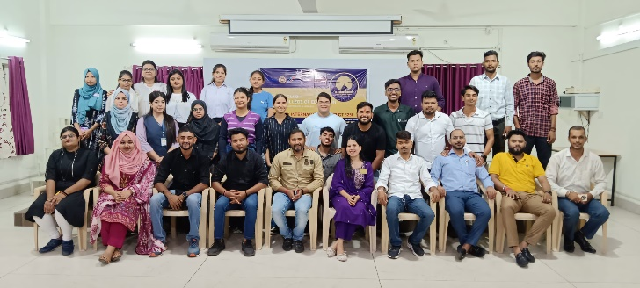
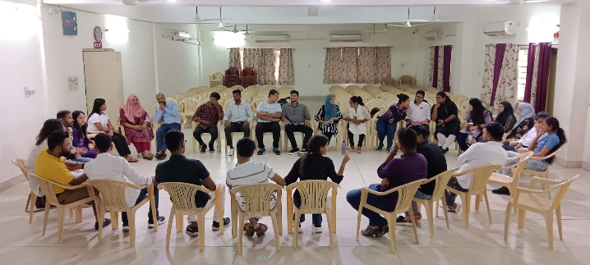
Event Photographs:

- Name of the event: Rotaract Club President Celebrates Birthday
Date and time: 6th July 2024
Mode of activity: In-person
Nature of activity: Club Services
Venue: D.B.M.S English College of Education
Guest: DRR Rtr. Rinku Kumar, DRS Rtr. Moushika Singha and other District delegates
Number of Participants: 2
Number of audiences: 30
Announcement of activity: 6th July 2024
Detailed Description: Rotaract Club of Karim City College President, Rtr. Md Shahid Raza celebrated his birthday on July 6, 2024, after a fellowship meet organised by Rotaract Club of D.B.M.S College of Education. The celebration was attended by members of Rotaract District 3250 and representatives from multiple Rotaract clubs, including DBMS College of Education, Green City, and Mrs. KMPM Vocational College. The event was a joyous occasion marked by camaraderie and shared celebrations.
Event Photographs:
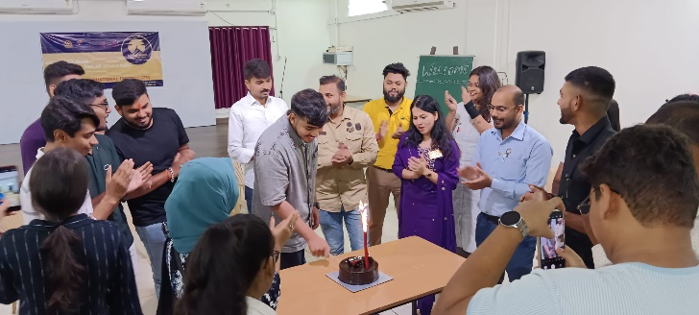
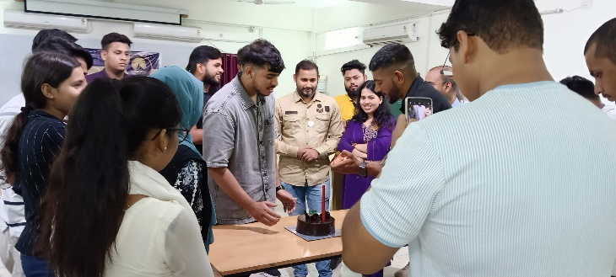

Outcomes:
- Strengthened Fellowship – The event reinforced bonds among Rotaractors from different clubs, fostering unity and friendship within Rotaract District3250.
- Boosted Morale & Engagement – Celebrating a leader’s birthday in a group setting enhanced camaraderie, motivating members for future collaborations.
- Inter-Club Networking – Representatives from multiple clubs (e.g., DBMS, Green City, KMPM) connected, paving the way for potential joint projects.
- Positive Club Image – The joyful gathering showcased the Rotaract Club of Karim City College as an active and socially vibrant group.
- Memorable Experience – The celebration created a sense of belonging, encouraging continued participation in Rotaract activities.
A perfect blend of fun and fellowship to energize the Rotaract community!

- Name of the event: Career Catalyst Webinar: A Joint Endeavor
Date and time: 12th July 2024
Mode of activity: Online
Nature of activity: International Services
Venue: Zoom Meeting
Guest:Mr. Kshitij Bhatia
Number of Participants: 8
Number of audiences: 103
Announcement of activity: 9th July 2024
Detailed Description: The Rotaract Club of Karim City College has partnered with the Rotaract Club of Delhi South East to organize a career guidance webinar titled "Career Catalyst: Unlock Your Potential." Eight members attended the informative session led by Mr. Kshitij Bhatia as the keynote speaker.
The webinar was conducted online via Zoom. The collaboration aimed to provide valuable career insights and support to young professionals.
Event Photographs:
Outcomes:
- Career Clarity & Guidance – Attendees gained practical insights, industry knowledge, and actionable advice to navigate their professional paths effectively.
- Skill Enhancement – Exposure to expert perspectives helped participants identify key skills needed for career growth.
- Inter-Club Collaboration Success – The partnership between Rotaract Club of Karim City College and Rotaract Club of Delhi South East strengthened, setting a precedent for future joint initiatives.
- Networking Opportunities – Participants connected with the speaker (Mr. Kshitij Bhatia) and fellow attendees, expanding their professional networks.
- Increased Engagement – The webinar boosted member participation and interest in career-focused Rotaract programs.
- Digital Reach & Accessibility – The online format (Zoom) allowed wider accessibility, making career guidance available beyond geographical limits.
A productive session that empowered attendees while fostering impactful collaboration!

- Name of the event: Rotaract Club of Karim City College Attends Installation Ceremony
Date and time: 13th July 2024
Mode of activity: In-person
Nature of activity: Club Services
Venue: Sukh Sagar Restaurant
Guest: District delegates
Number of Participants: 2
Number of audiences: 22
Announcement of activity: 11th July 2024
Detailed Description: Members of the Rotaract Club of Karim City College attended the 8th Installation Ceremony of the Rotaract Club of Kalimati. The event served as a platform for camaraderie and networking among Rotaractors from both clubs. As the Rotaract Club of Kalimati ushered in a new leadership team, the members of Karim City College extended their congratulations and best wishes for a successful year ahead.
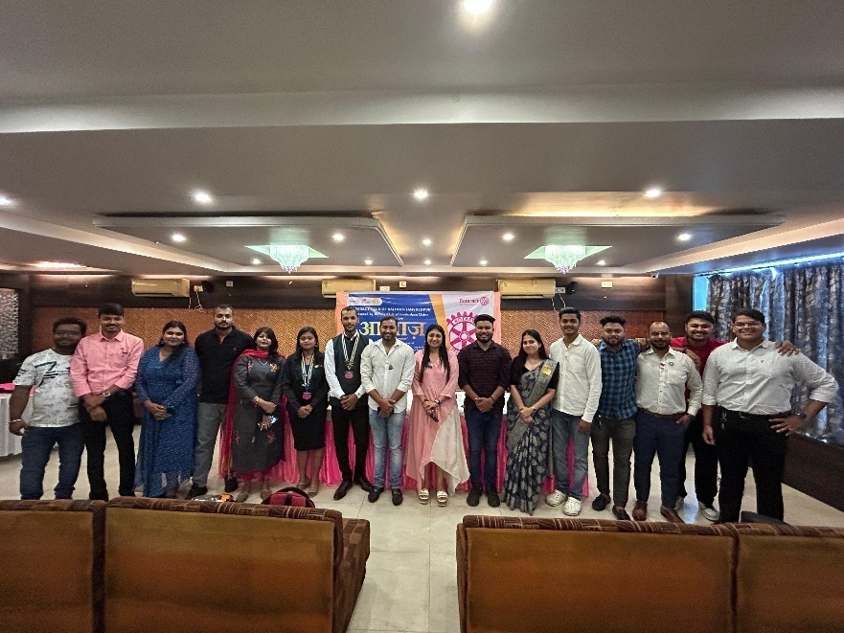
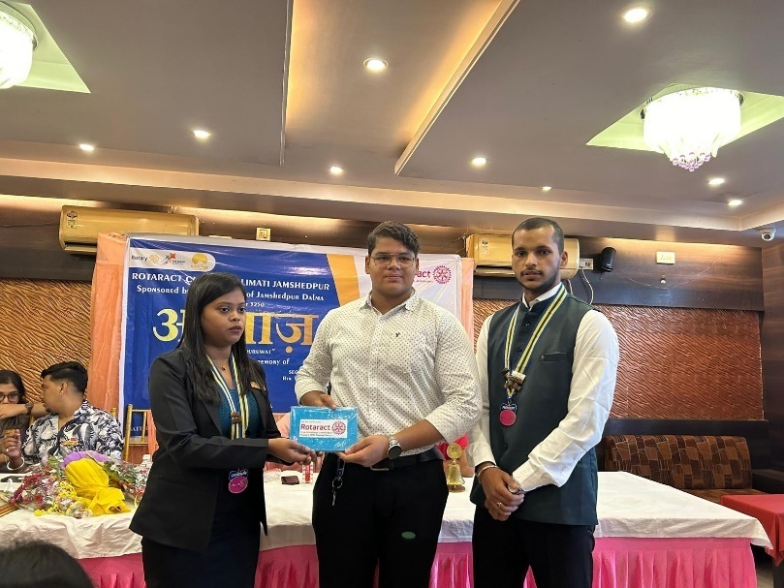
Event Photographs:

Outcomes:
- Strengthened Inter-Club Relations – The presence of Karim City College Rotaractors fostered goodwill and solidarity with the Rotaract Club of Kalimati, paving the way for future collaborations.
- Networking & Fellowship – Members built connections with Rotaractors from other clubs, expanding their professional and social networks within the Rotary ecosystem.
- Inspiration for Leadership – Witnessing the new team’s installation motivated attendees with fresh ideas for their own club’s governance and projects.
- Shared Best Practices – Observing Kalimati’s event execution provided insights for organizing future installations or ceremonies.
- Enhanced Visibility – Active participation demonstrated Karim City College Rotaract Club’s commitment to the district’s Rotaract community.
- Team Bonding – Members returned with a renewed sense of purpose and camaraderie after celebrating a fellow club’s milestone.
A meaningful engagement that reinforced unity and Rotaract spirit!

- Name of the event: Rotaract Club of Karim City College Participates in District Installation Ceremony
Date and time: 14th July 2024
Mode of activity: In-person
Nature of activity: Club Services
Venue: Auditorium, Karim City College
Guest:DG Rtn. Bipin Chachan and delegates from Rotary Clubs
Number of Participants: 4
Number of audiences: 64
Announcement of activity: 5th July 2024
Detailed Description: Rotaract Club of Karim City College was actively involved in the 38th Installation Ceremony of District Rotaract Organisation 3250, held on July 14, 2024. The event marked a significant milestone for the organization as it welcomed Rinku Kumar as the newly installed District Rotaract Representative (DRR).
The ceremony provided an excellent platform for club members to engage with fellow Rotaractors from the district and witness the leadership transition.
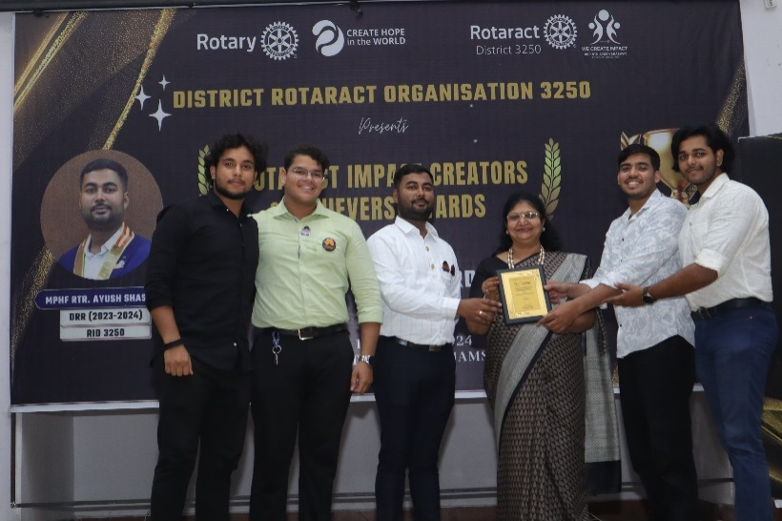
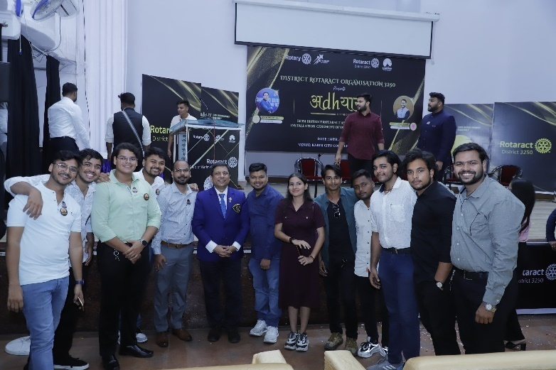
Event Photographs:

Outcomes:
- District-Level Networking – Strengthened connections with Rotaractors across D3250, fostering future collaborations.
- Leadership Inspiration – Witnessing the DRR installation motivated members with fresh governance ideas.
- Club Visibility – Active participation highlighted Karim City College’s commitment to the district’s Rotaract community.
- Team Bonding – Shared experience boosted camaraderie among attending members.
- Strategic Alignment – Gained clarity on district goals for 2024-25 under the new DRR’s leadership.
An impactful engagement!

- Name of the event: Rotaract Club of Karim City College successfully conducted its monthly Roti Day
Date and time: 15th July 2024
Mode of activity: In-person
Nature of activity: Community Services
Venue: Local areas of Dev Nagar
Guest: N/A
Number of Participants: 21
Number of audiences: 25
Announcement of activity: 12th July 2024
Detailed Description: Rotaract Club of Karim City College successfully hosted its monthly Roti Day, providing sustenance to approximately 50 individuals in need. The club distributed a variety of food items, including bread, roti, biscuits, and other homemade delicacies. This initiative underscores the club’s commitment to community service and addressing hunger in the local area of Dev Nagar.
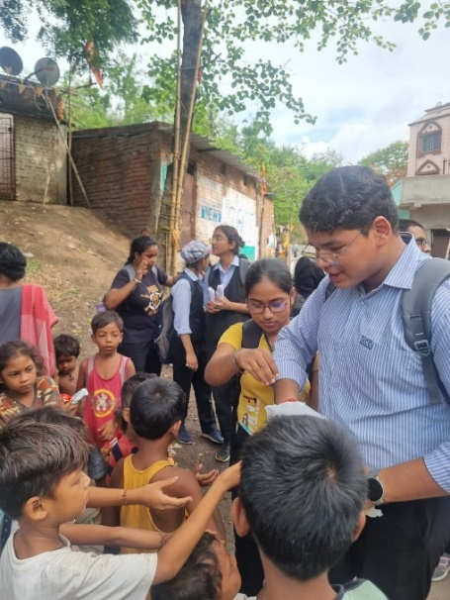
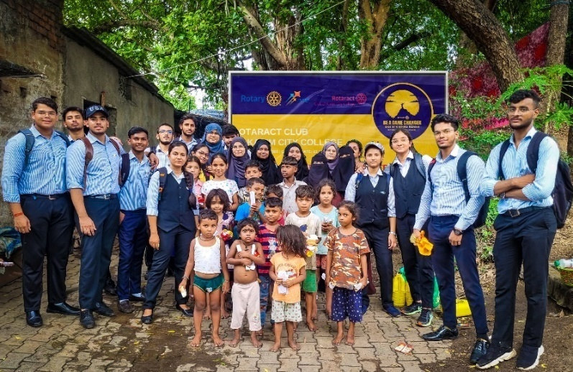
Event Photographs:

Outcomes:
- Immediate Hunger Relief – Provided nutritious meals to 50+ underprivileged individuals, addressing food insecurity in Dev Nagar.
- Community Impact – Strengthened the club’s bond with locals, fostering goodwill and trust.
- Member Engagement – Rotaractors gained hands-on experience in grassroots service, reinforcing empathy and teamwork.
- Awareness & Advocacy – Highlighted local hunger issues, inspiring others to contribute to similar causes.
- Sustainable Service Model – Demonstrated the effectiveness of simple, recurring initiatives (like monthly Roti Day) for lasting change.
A small effort with big hearted results!

- Name of the event: Rotaract Club of Karim City College Arranges Blood in Time of Need
Date and time: 18th July 2024
Mode of activity: In-person
Nature of activity: Community Services
Venue: Jamshedpur Blood Bank
Guest: N/A
Number of Participants: 4
Number of audiences: N/A
Announcement of activity:
Detailed Description: Rotaract Club of Karim City College stepped up to help a community member in urgent need of blood. The club's prompt action ensured that the required blood units were arranged, potentially saving a life.
This act of service highlights the important role that Rotaract clubs play in supporting their communities. Through blood donation drives and other initiatives, these organizations contribute significantly to the well-being of others.
Event Photographs:

Outcomes:
- Critical Need Fulfilled – Immediate blood requirement was met, directly aiding a life-threatening situation.
- Club Responsiveness – Demonstrated the club’s ability to mobilize resources swiftly in emergencies.
- Community Trust – Strengthened the club’s reputation as a reliable support system in crises.
- Awareness Boost – Highlighted the ongoing need for blood donors, potentially inspiring future drives.
- Member Motivation – Reinforced Rotaractors’ commitment to humanitarian service through tangible impact.
Proof that quick action + collective effort = lives changed!

- Name of the event: Nirmalya- No Bags Day
Date and time: 20th July 2024
Mode of activity: In-person
Nature of activity: Club Service
Venue: Zikra Girls Creative School
Guest:N/A
Number of Participants: 9
Number of audiences: 22
Announcement of activity: 17th July 2024
Detailed Description: Rotaract Club of Karim City College has successfully launched its new initiative, Nirmalya(निर्मालय) at Zikra Girls Creative School. On this special "No Bags Day," the members engaged with approximately 20 students through interactive sessions, teaching them moral values and traffic safety while enjoying various activities and games. It was a memorable day filled with learning and joy.
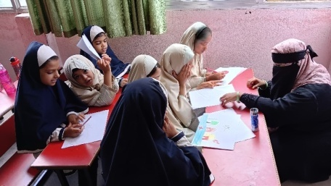
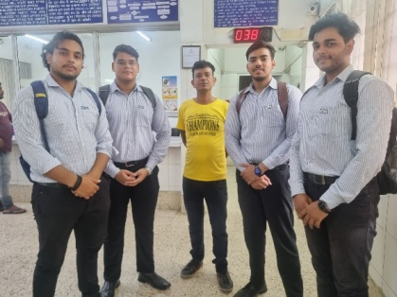
Event Photographs:
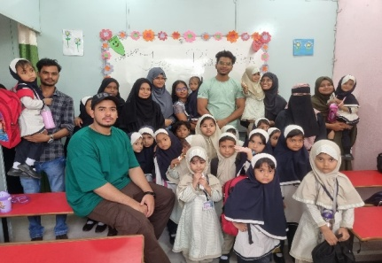

Outcomes:
- Value-Based Education – Students learned essential moral values and traffic safety in an engaging, interactive way.
- Joyful Learning – The "No Bags Day" approach made education fun through games and activities, leaving a lasting impression.
- Community Connection – Strengthened ties between the Rotaract Club and the school, opening doors for future collaborations.
- Youth Empowerment – Encouraged creativity and confidence in young students through participatory sessions.
- Club Impact – Members gained hands-on experience in child-centric service, reinforcing their commitment to grassroots change.
A perfect blend of education, safety, and happiness!

- Name of the event: Justice without Borders - Webinar
Date and time: 25th July 2024
Mode of activity: Online
Nature of activity: International Services
Venue: Google Meet
Guest:Dr. Sudhir Kumar Singh
Number of Participants: 12
Number of audiences: 68
Announcement of activity: 22nd July 2025
Detailed Description: Rotaract Club of Karim City College in collaboration with Rotaract Club of Dyal Singh College organized an international webinar titled “Justice without Borders” to mark World Day for International Justice.
The event featured a keynote address by Dr. Sudhir Kumar Singh, an eminent expert in International Relations. Dr. Singh provided valuable insights into the complexities of global justice. The webinar aimed to foster awareness and understanding of justice challenges worldwide.
Event Photographs:
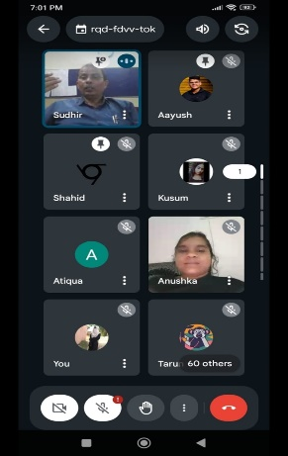
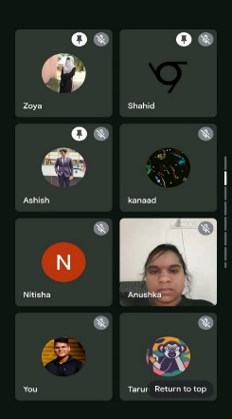

Outcomes:
- Global Awareness – Enhanced participants' understanding of international justice challenges and mechanisms.
- Expert Insights – Dr. Sudhir Kumar Singh’s address provided valuable knowledge on cross-border legal frameworks.
- Inter-Club Collaboration – Strengthened ties between Karim City College and Dyal Singh College Rotaract clubs.
- Youth Engagement – Inspired attendees to explore careers or advocacy in international law and justice.
- Digital Reach – The online format allowed a wider audience to engage with critical global issues.
A thought-provoking initiative with global impact!

- Name of the event: Rotaract Club of Karim City College Installs New Board
Date and time: 27th July 2024
Mode of activity: In-person
Nature of activity: Club Services
Venue: Narbheram Hansraj English School
Guest:PDG Rtn. Pratim Banerjee
Number of Participants: 3
Number of audiences: 45
Announcement of activity: 25th July 2024
Detailed Description: Rotary Club of Jamshedpur West hosted the installation ceremony of the new board of the Rotaract Club of Karim City College on July 27, 2024, at Narbheram Hansraj English School. Rtr. Md Shahid Raza was officially installed as President, Rtr. Aayush Pathak as Secretary, and Rtr. Atiqua Mahfooz as Treasurer. The ceremony marked the beginning of a new leadership era for the club
Event Photographs:
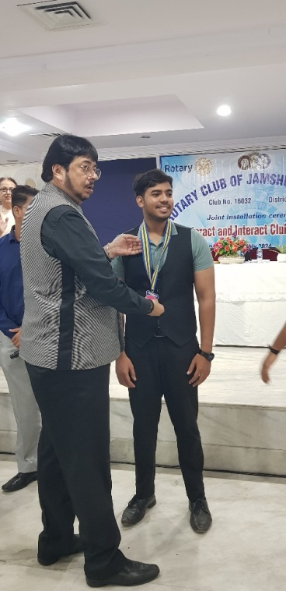
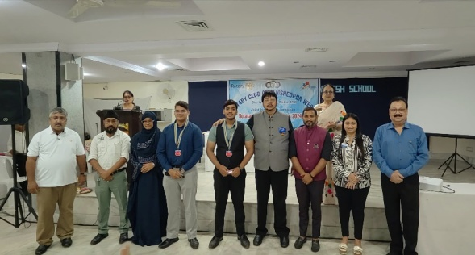

Outcomes:
- Leadership Transition – Smooth handover to the new board (President, Secretary, Treasurer) for 2024-25.
- Club Motivation – Energized members with a clear vision for the year ahead.
- Rotary-Rotaract Bond – Strengthened ties with the Rotary Club of Jamshedpur West as mentors.
- Credibility & Visibility – Formal ceremony enhanced the club’s reputation in the Rotary ecosystem.
- Strategic Direction – Set the tone for upcoming projects under fresh leadership.
A promising start to the new Rotaract year!

- Name of the event: Emotion Warriors- Men’s Mental Health Webinar
Date and time: 28th July 2024
Mode of activity: Online
Nature of activity: International Services
Venue: Google Meet
Guest:Aahkash Tandon, TEDx presenter
Number of Participants: 8
Number of audiences: 36
Announcement of activity: 27th July 2024
Detailed Description: Rotaract Club of Karim City College actively participated in an online event focused on men's mental health under the project "Emotion Warriors" on July 28, 2024.
The event provided a valuable platform for club members to learn about the importance of mental health, especially among men. By participating, members gained a deeper understanding of the challenges faced by men and the significance of addressing mental health stigma.
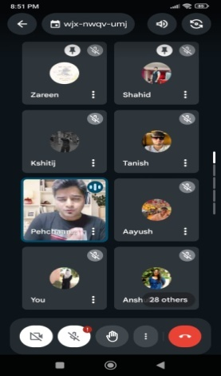
Event Photographs:

Outcomes:
- Mental Health Awareness – Increased understanding of men’s mental health challenges and stigma.
- Skill Development – Members learned tools to support mental well-being in themselves and others.
- Reduced Stigma – Open discussions helped normalize conversations around mental health.
- Club Engagement – Active participation strengthened member involvement in social causes.
- Future Advocacy – Inspired potential follow-up initiatives on mental health awareness.
A small step toward breaking barriers in mental health!

- Name of the event: Fellow club’s Installation Ceremony
Date and time: 30th July 2024
Mode of activity: In-person
Nature of activity: Club Services
Venue: Mrs. KMPM Vocational College
Guest:PDG Rtn. Pratim Banerjee
Number of Participants: 2
Number of audiences: 32
Announcement of activity: 28th July 2024
Detailed Description: Rotaract Club of Karim City College enthusiastically participated in the Installation Ceremony of the Rotaract Club of Mrs KMPM Vocational College. The event served as a platform for fostering camaraderie and collaboration between the two clubs. As the Rotaract Club of Mrs KMPM Vocational College inducted its new leadership team, members from Karim City College extended their congratulations and best wishes for a successful year ahead.
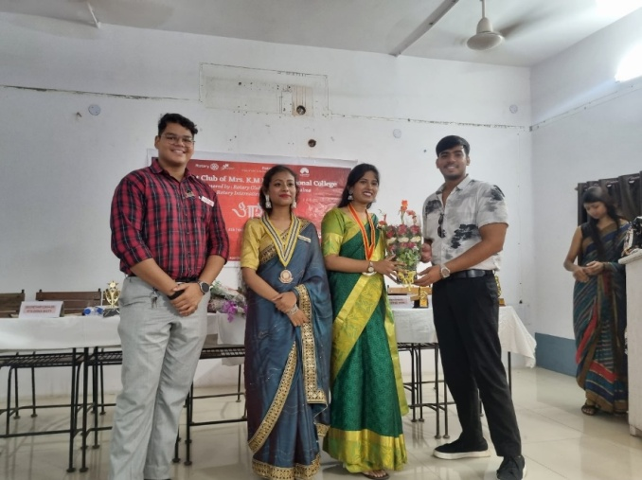
Event Photographs:

Outcomes:
- Strengthened Inter-Club Bonds – Enhanced collaboration and camaraderie between the two clubs.
- Networking Opportunities – Members built connections for future joint initiatives.
- Leadership Inspiration – Witnessing the new team’s installation motivated fresh ideas for club governance.
- Visibility & Goodwill – Active participation showcased Karim City College’s commitment to the Rotaract community.
- Shared Best Practices – Gained insights into event organization and leadership transitions.
A productive step toward collective growth!

- Name of the event: Maitri 2.0 "Gup Shup" Webinar
Date and time: 30th July 2024
Mode of activity: Online
Nature of activity: International Services
Venue: Google Meet
Guest:N/A
Number of Participants: 8
Number of audiences: 86
Announcement of activity: 29th July 2024
Detailed Description: Rotaract Club of Karim City College and the Rotaract Club of DAVIM jointly organized a webinar titled "Gup Shup". The virtual event provided a platform for Rotaractors to connect, share experiences, and build lasting friendships. Participants engaged in lively discussions about their bonds within and outside the Rotaract community. The webinar also offered a unique opportunity for cultural exchange as attendees shared insights into their diverse backgrounds.
Event Photographs:
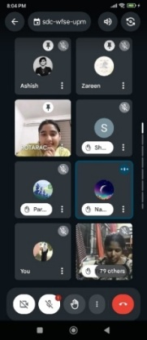
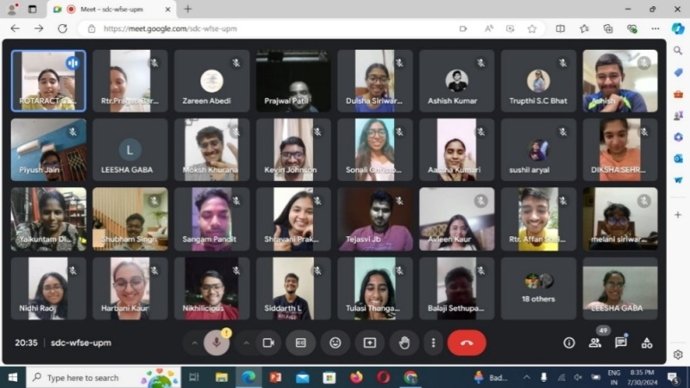

Outcomes:
- Strengthened Bonds – Enhanced camaraderie and friendships among Rotaractors from both clubs.
- Cultural Exchange – Participants gained insights into diverse backgrounds, fostering inclusivity.
- Inter-Club Collaboration – Successful partnership set the stage for future joint initiatives.
- Informal Networking – Laid-back discussions created a comfortable space for open sharing and connection.
- Member Engagement – Boosted enthusiasm and participation in club activities through meaningful interactions.
A perfect blend of fun and fellowship!

- Name of the event: Rotaract Club Promotes Road Safety Through Nukkad Natak
Date and time: 31st July 2024
Mode of activity: In-person
Nature of activity: Community Services
Venue: Karim City College
Guest:Dr. Mohammad Reyaz, Principal, Karim City College, Rtn Ashok Kumar Jha and other faculty members
Number of Participants: 12
Number of audiences:
Announcement of activity:
Detailed Description: Rotaract Club of Karim City College took a proactive step towards road safety by performing a compelling Nukkad Natak on July 31, 2024. As part of the district project "Road Guardians," the drama aimed to educate fellow students about the importance of traffic rules, helmet usage, and responsible driving.The performance, witnessed by the Rotary Club of Jamshedpur West, Principal Mohammad Reyaz, and other faculty members, was well-received. The Rotaract Club’s initiative successfully raised awareness about road safety among the college community.
Event Photographs:

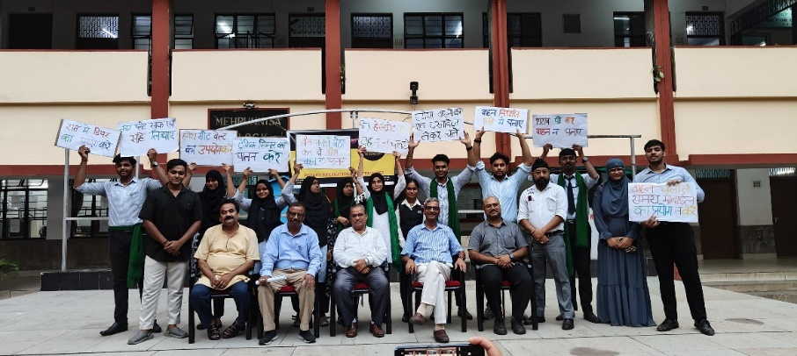
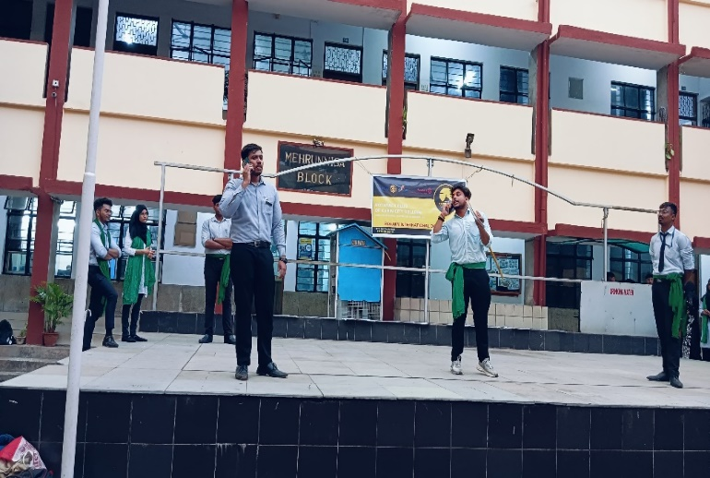

Outcomes:
- Road Safety Awareness – Effectively educated students on traffic rules, helmet use, and responsible driving.
- Community Engagement – Gained support from Rotary Club of Jamshedpur West and college faculty, amplifying impact.
- Creative Advocacy – Used Streettheatre (Nukkad Natak) as an engaging tool for social messaging.
- Student Participation – Encouraged peer-to-peer learning, making safety norms more relatable.
- District Alignment – Contributed to the broader "Road Guardians" project, reinforcing Rotaract’s commitment to public welfare.
A powerful blend of art and activism!

- Name of the event:Celebrating a Club Member's Birthday
Date and time: 08th August 2024
Mode of activity: In-person
Nature of activity: Club Services
Venue: College Campus
Guest:N/A
Number of Participants: --
Number of audiences: 9
Announcement of activity: 07th August 2024
Detailed Description: Rotaract Club of Karim City College celebrated the birthday of Rtr Annu Kumari on August,2024. The celebration was an opportunity for club members to bond and enjoy each other's company.
Number of beneficiaries: 9 | Expenses incurred: Rs. 850/-
Event Photographs:

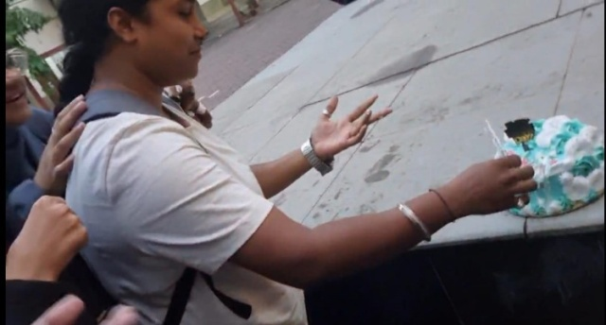
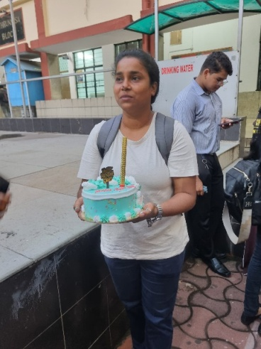

Outcomes:
- Strengthened Fellowship – Enhanced camaraderie and bonding among 9 club members.
- Boosted Morale – Created a joyful atmosphere, reinforcing team spirit and motivation.
- Cost-Effective Celebration – Managed a memorable event within a budget of ₹850.
- Member Appreciation – Recognized Rtr. Annu Kumari’s contributions, fostering a sense of belonging.
- Positive Club Culture – Reinforced the importance of work-life balance and celebrating milestones together.
A simple yet impactful celebration!

- Name of the event:Lung Cancer Awareness Webinar
Date and time: 09th August 2024
Mode of activity: Online
Nature of activity: International Services
Venue: Google Meet
Guest:
Number of Participants: 6
Number of audiences: 62
Announcement of activity:
Detailed Description: Rotaract Club of Karim City College, in collaboration with the Rotaract Club of Shaheed Bhagat Singh College, organized a lung cancer awareness webinar on August 9, 2024. A total of six members attended the virtual event, where they learned about the causes, symptoms, prevention strategies, and early detection methods for lung cancer. The webinar aimed to equip club members with knowledge to promote awareness and educate their community about this serious health issue.
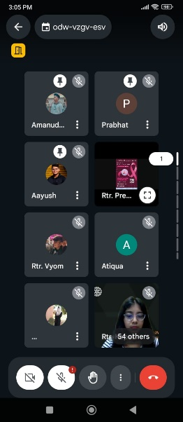
Event Photographs:
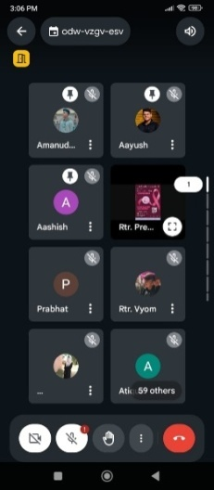

Outcomes:
- Health Education – Members gained vital knowledge about causes, symptoms, prevention, and early detection of lung cancer.
- Awareness Advocacy – Equipped attendees to educate their communities, amplifying the webinar’s impact beyond participants.
- Inter-Club Collaboration – Strengthened ties with Rotaract Club of Shaheed Bhagat Singh College for future health initiatives.
- Digital Reach – Leveraged a virtual platform to disseminate critical health information efficiently.
- Preventive Mindset – Inspired proactive health behaviours (e.g., anti-smoking advocacy, regular check-ups) among members.
A small but meaningful step toward public health awareness!

- Name of the event:Personality Enhancement Webinar
Date and time: 10th August 2024
Mode of activity: Online
Nature of activity: International Services
Venue: Google Meet
Guest:
Number of Participants:
Number of audiences:
Announcement of activity:
Detailed Description: Rotaract Club of Karim City College actively participated in a Personality Enhancement webinar on August 10, 2024. A total of nine members attended the virtual event, where they learned valuable skills and techniques to improve their communication, self-confidence, and overall personality. The webinar provided a platform for the club members to develop their personal and professional growth, empowering them to become more effective leaders and individuals.
Number of Beneficiaries:68 | Expenses Incurred: ₹0/-
Event Photographs:
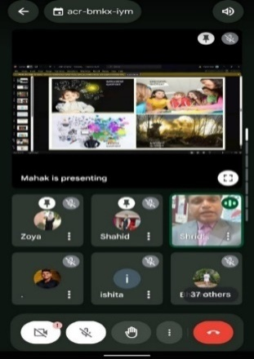
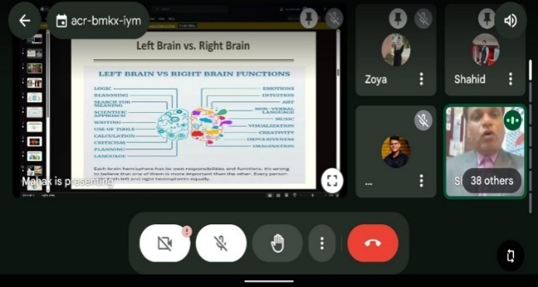

Outcomes:
- Skill Development – Members gained practical tools to boost communication, confidence, and leadership abilities.
- Personal Growth – Empowered attendees to refine their professional demeanor and interpersonal skills.
- Cost-Effective Learning – Achieved impactful training at zero expense (₹0), maximizing resource efficiency.
- Scalable Reach – Indirectly benefited 68+ individuals through knowledge-sharing by participants.
- Club Competency – Enhanced members’ readiness for roles in Rotaract and future careers.
A high-value, zero-cost investment in human potential!

- Name of the event:Fitness & Wellness Webinar
Date and time: 10th August 2024
Mode of activity: In-person
Nature of activity: International Services
Venue: Google Meet
Guest:N/A
Number of Participants:
Number of audiences:
Announcement of activity:
Detailed Description: Health is the biggest wealth of a person. Rotaract Club of Karim City College actively participated in the Fitness & Wellness webinar organized by RAC DPSRU on August 10, 2024. A total of five members attended the virtual event, where they learned about the importance of maintaining a healthy lifestyle, effective workout routines, and proper nutrition. The webinar provided valuable insights for the club members to improve their physical and mental well-being, promoting a healthier and more balanced lifestyle.Number of Beneficiaries:57 | Expenses Incurred: ₹0/-
Event Photographs:
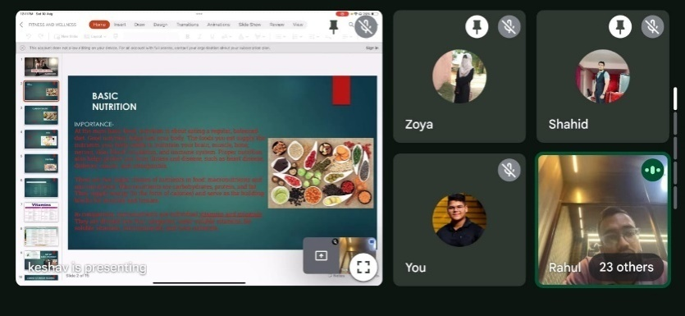

Outcomes:
- Holistic Health Awareness – Members learned the importance of physical fitness, mental wellness, and balanced nutrition for long-term well-being.
- Practical Knowledge – Gained actionable tips on workout routines, diet plans, and stress management techniques.
- Cost-Free Empowerment – Acquired valuable health insights at zero cost (₹0), making wellness education accessible.
- Multiplier Effect – Indirectly reached 57+ beneficiaries as attendees shared learnings with peers and community.
- Club Culture Shift – Inspired a health-conscious mindset among members, encouraging future wellness initiatives.
Proving that good health is truly the greatest wealth!

- Name of the event:Rotaract Pathshala: Training Session
Date and time: 11th August 2024
Mode of activity: In-person
Nature of activity: Club Services
Venue: Kerala Samajam Model School
Guest:PDG Rtn Pratim Banerjee and other Rotarians
Number of Participants: 18
Number of audiences: 67
Announcement of activity:
Detailed Description: Rotaract Club of Karim City College participated in the Rotaract Pathshala training session on August 11, 2024. Eighteen club members attended the event, gaining valuable insights and skills through the training provided by experienced Rotarians. The session was a valuable learning experience for the Rotaractors.
Number of Beneficiaries:more than 60 | Expenses Incurred: ₹0/-
Event Photographs:
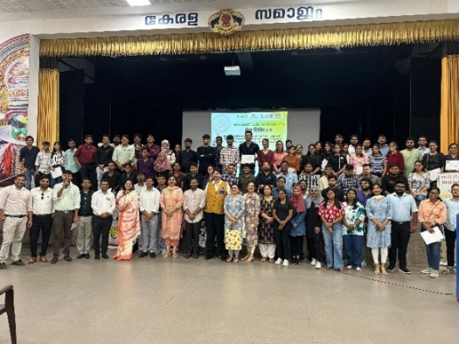
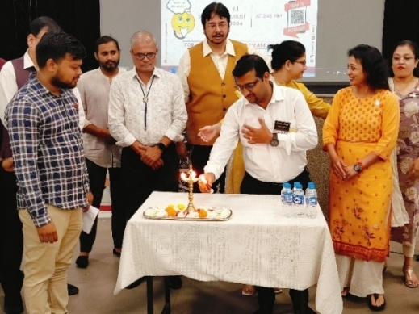

Outcomes:
- Capacity Building – 18 members gained practical skills and Rotaract knowledge from expert Rotarians, enhancing club operations.
- Leadership Development – Equipped attendees with tools to take on impactful roles in projects and governance.
- Cost-Free Learning – High-quality training achieved at zero expense (₹0), optimizing resource use.
- Expanded Reach – Indirectly benefited 60+ individuals as trained members share insights with peers.
- District Alignment – Strengthened connection with Rotary mentors, ensuring adherence to best practices.

- Name of the event:Global Youth Dialogue on Climate Change
Date and time: 12th August 2024
Mode of activity: Online
Nature of activity: International Services
Venue: Google Meet
Guest:
Number of Participants: 6
Number of audiences: 57
Announcement of activity:
Detailed Description: Rotaract Club of Karim City College collaborated with Rotaract Club of Baneshwor Royal in the Global Youth Dialogue on Climate Change webinar on August 12, 2024. Six members from the club represented their institution and engaged in discussions surrounding climate change and its global implications. This webinar provided a valuable platform for young individuals to share ideas, learn from experts, and contribute to the global conversation on addressing the pressing challenges posed by climate change.
Number of Beneficiaries:58 | Expenses Incurred: ₹0/-
Event Photographs:
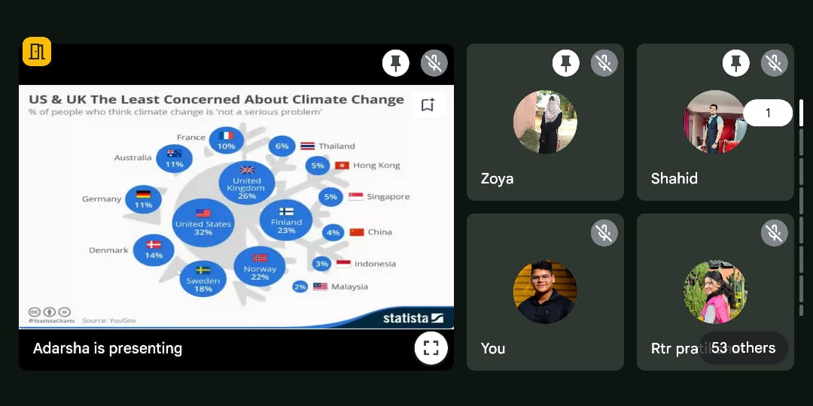
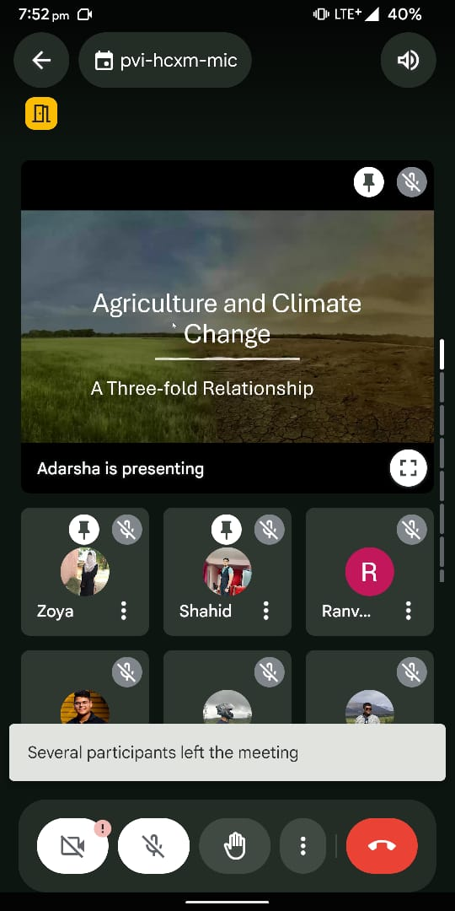

Outcomes:
- Climate Awareness – Members deepened their understanding of climate change impacts and solutions, fostering informed advocacy.
- Youth Empowerment – Provided a platform for young voices to contribute to global environmental discourse.
- Inter-Club Collaboration – Strengthened ties with Rotaract Club of Baneshwor Royal for future sustainability projects.
- Cost-Free Impact – Achieved meaningful engagement at zero cost (₹0), maximizing outreach.
- Multiplier Effect – Indirectly influenced 58+ individuals as attendees shared learnings with peers and communities.
Small steps today for a greener tomorrow!

- Name of the event:गौ राक्षक
Date and time: 14th August 2024
Mode of activity: In-person
Nature of activity: Community Services
Venue: Local areas of Sakchi
Guest:N/A
Number of Participants: 4
Number of audiences:
Announcement of activity:
Detailed Description: Rotaract Club of Karim City College, in collaboration with the Rotaract Club of Mrs. KMPM Vocational College, successfully executed the 'गौराक्षक' project on August 14, 2024. The project aimed to enhance the visibility of stray cows, reducing the risk of accidents. Over 20 reflective cattle collars were distributed to stray cows in the area. By making the cows more noticeable to drivers, especially at night or in low-light conditions, the project helped to ensure their well-being.
Number of Beneficiaries:more than 20 | Expenses Incurred: ₹1800/-

Event Photographs:
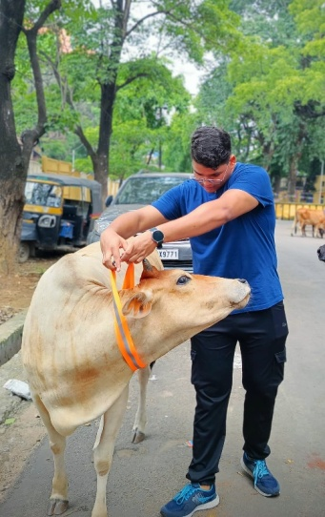

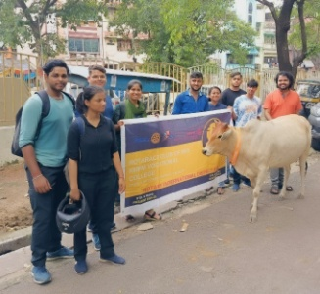

Outcomes:
- Enhanced Road Safety – Reflective collars reduced accident risks for 20+ stray cows, protecting both animals and motorists.
- Community Awareness – Highlighted the importance of animal welfare and coexistence in urban spaces.
- Inter-Club Synergy – Successful collaboration with Rotaract Club of Mrs. KMPM Vocational College strengthened partnerships for future initiatives.
- Sustainable Impact – Low-cost, high-impact solution with long-term benefits for the locality.
- Rotaract Visibility – Demonstrated the club’s innovative approach to addressing local challenges, inspiring similar projects.
A small step for cows, a giant leap for compassion!

- Name of the event:Celebrating India's 78th Independence Day
Date and time: 15th August 2024
Mode of activity: In-person
Nature of activity: Community Services
Venue: Tatanagar Railway Station
Guest:Rotary Club of Jamshedpur Dalma
Number of Participants: 4
Number of audiences: more than 30
Announcement of activity:
Detailed Description: Rotaract Club of Karim City College, invited by Rotary Club of Dalma Jamshedpur, in collaboration with Rotaract Club of Mrs. KMPM Vocational College, and Rotaract Club of Kalimati Jamshedpur, participated in the celebration of India's 78th Independence Day.Club members actively contributed to the event, including creating a vibrant rangoli at Tatanagar Railway Station to symbolize the nation's diversity and unity. The event culminated in a flag hoisting ceremony performed by ARM Abhishek Singhal, followed by the singing of the national anthem. This experience fostered a strong sense of patriotism and camaraderie among the participating clubs, reaffirming the importance of community involvement and collaboration.

Event Photographs:
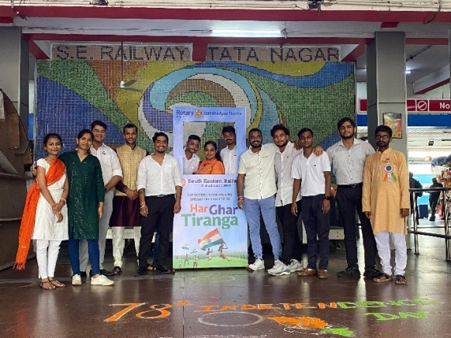
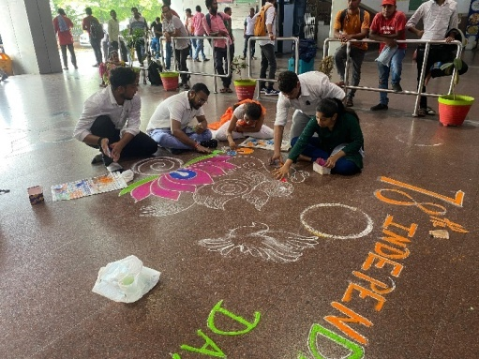

Outcomes:
- Patriotic Engagement – Strengthened national pride through flag hoisting, rangoli art, and national anthem, uniting participants in celebration.
- Inter-Club Unity – Fostered camaraderie among 4 clubs (Rotary + 3 Rotaracts), setting a precedent for future joint initiatives.
- Community Visibility – Vibrant rangoli at Tatanagar Railway Station showcased creativity and patriotism to the public.
- Symbolic Impact – Highlighted India’s diversity and unity through collaborative art and ceremonies.
- Leadership Participation – ARM Abhishek Singhal’s involvement reinforced Rotary-Rotaract mentorship and shared values.
A tricolour tribute to unity in diversity!

- Name of the event:Cultivating Healthy and Meaningful Relationships: A Webinar
Date and time: 20th August 2024
Mode of activity: Online
Nature of activity:International Services
Venue: Google Meet
Guest:
Number of Participants: 10
Number of audiences: 97
Announcement of activity:
Detailed Description: Rotaract Club of Karim City College, in collaboration with the Rotaract Club of Ashoka Artisans, organized a webinar on 'Cultivating Healthy and Meaningful Relationships' on June 20, 2024. The webinar provided participants with valuable insights and strategies for building and maintaining strong interpersonal relationships. The event aimed to promote mental health and well-being within the community.
Number of Beneficiaries:98 | Expenses Incurred: ₹0/-
Event Photographs:
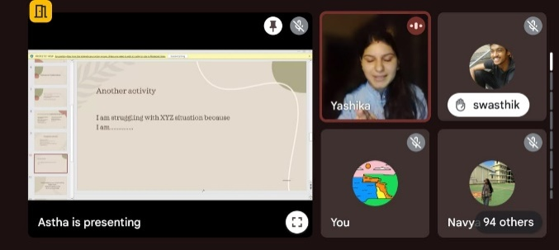
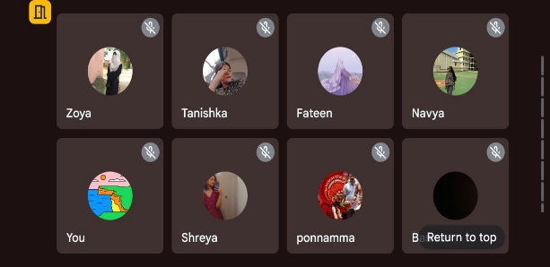

Outcomes:
- Relationship Skills Development – Participants gained practical strategies for building trust, communication, and emotional intelligence in personal and professional relationships.
- Mental Health Awareness – Highlighted the link between healthy relationships and well-being, reducing stigma around emotional health discussions.
- Inter-Club Collaboration – Strengthened ties with Rotaract Club of Ashoka Artisans, paving the way for future joint initiatives.
- Cost-Free Impact – Delivered high-value content at ₹0 expense, making psychoeducation accessible to 98+ beneficiaries.
- Community Ripple Effect – Attendees shared learnings with peers, amplifying the webinar’s reach beyond direct participants.
Because strong relationships build stronger communities!

- Name of the event:Safety: A Joke (Webinar)
Date and time: 25th August 2024
Mode of activity: Online
Nature of activity: International Services
Venue: Google Meet
Guest:
Number of Participants: 8
Number of audiences: 75
Announcement of activity:
Detailed Description: Rotaract Club of Karim City College participated in a webinar titled 'Safety: A Joke,' organized by the Rotaract Club of Anand Institute of Higher Technology in collaboration with the Rotaract Club of Ashok Artisans on August 25, 2024. The webinar focused on the critical issue of women's safety, highlighting its importance and addressing concerns related to women's security.
Number of Beneficiaries:55 | Expenses Incurred: ₹0/-
Event Photographs:
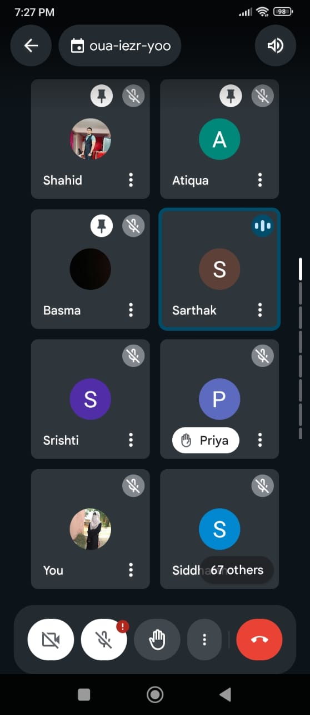

Outcomes:
- Awareness Amplified – Highlighted critical women’s safety issues, equipping attendees with knowledge to identify and address risks.
- Provocative Dialogue – The bold theme sparked candid discussions on societal attitudes toward safety, challenging complacency.
- Inter-Club Solidarity – Collaboration with RAC Anand Institute & Ashok Artisans strengthened networks for future gender-safety initiatives.
- Zero-Cost Advocacy – Delivered impactful content at ₹0 expense, proving awareness doesn’t require a budget.
- Community Ripple Effect – 55+ participants became ambassadors for safety, sharing learnings to amplify impact.
Safety is no joke—but humour can be a hook for change!

- Name of the event:Stand up, Speak out! (Awareness Rally)
Date and time: 28th August 2024
Mode of activity: In-person
Nature of activity: Community Services
Venue: Bistupur
Guest:N/A
Number of Participants: 6
Number of audiences: >100
Announcement of activity:
Detailed Description: Six members of Rotaract Club of Karim city college actively took part participated in a rally organized to protest the sexual assault against Dr. Moumita Debnath. The rally was a joint effort by multiple organizations, including the NSS and students from other institutions. The participants marched through the streets with placards demanding justice for Dr. Debnath and all victims of sexual assault. The rally was supported by other Rotaract Clubs such as Rotaract Club of D.B.M.S Education College, and Rotaract Club of Kalimati Jamshedpur, demonstrating the power of unity in advocating for women's safety. The event concluded with a pledge to create a world free from violence against women.
Number of Beneficiaries:>100 | Expenses Incurred: ₹0/-
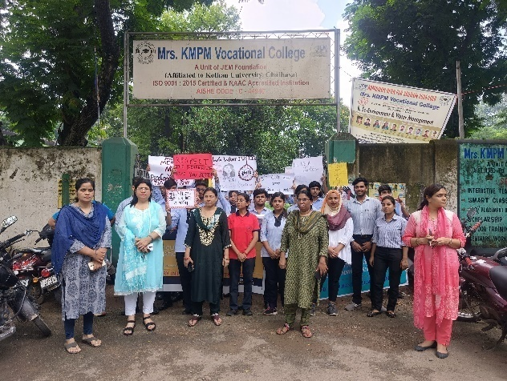
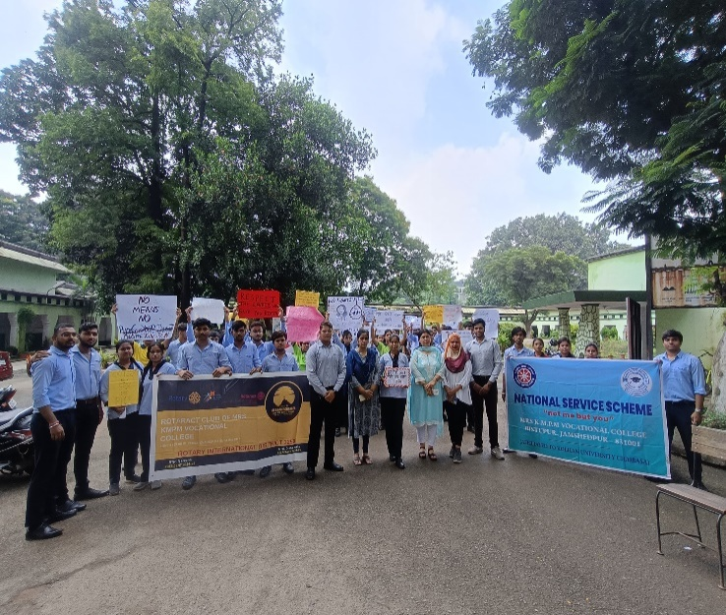
Event Photographs:

Outcomes:
- Collective Advocacy – Amplified voices demanding justice for sexual assault survivors, uniting Rotaract, NSS, and student communities.
- Public Awareness – Street march with placards drew attention to gender-based violence, sparking dialogue in the community.
- Inter-Club Solidarity – Collaboration with RAC D.B.M.S Education College and RAC Kalimati Jamshedpur showcased Rotaract’s united stand against violence.
- Empowerment Through Action – Participants took a public pledge to combat gender violence, translating outrage into commitment.
- Media & Societal Impact – Rally visibility pressured authorities to take such cases seriously and inspired bystanders to join the cause.
Silence is complicity—but today, the streets spoke loud!

- Name of the event:Debate Competition on Mental Health under District Project - आरोग्यम
Date and time: 31st August 2024
Mode of activity: In-person
Nature of activity: Community Services
Venue: RMS High School, Khutadih
Guest:N/A
Number of Participants: 4
Number of audiences: 30
Announcement of activity:
Detailed Description: Rotaract Club of Karim City College participated in a debate competition organized by Jeevan - Suicide Prevention Centre at RMS High School, Khutadih, on August 31, 2024. The competition was part of a stress management workshop for students, focusing on mental health, suicide, and suicidal behaviour. The club's participation helped to promote awareness and reduce the stigma associated with these issues. 4 members from the club participated in the competition.
Number of Beneficiaries:45 | Expenses Incurred: ₹0/-

Event Photographs:

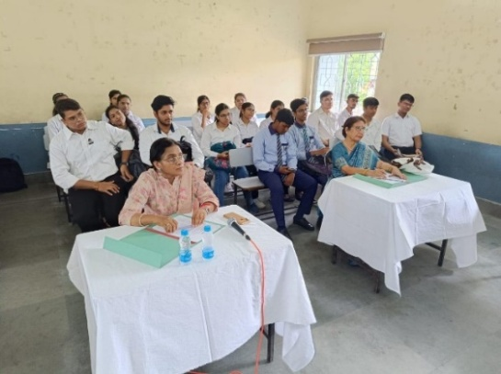
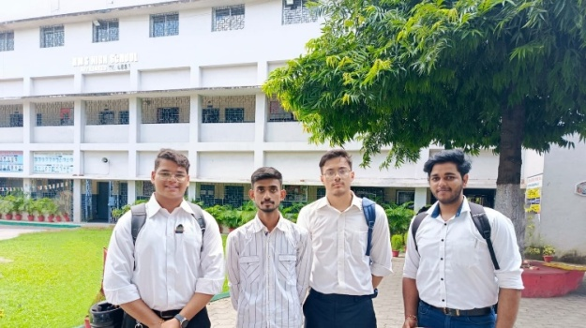

Outcomes:

Name of the event:Utkarsh: Heights of Excellence (Webinar)
Date and time: 31st August 2024
Mode of activity: Online
Nature of activity: Community Services
Venue: Zoom Meeting
Guest:Rtn Shivani Goel
Number of Participants: 6
Number of audiences: >35
Announcement of activity:
Detailed Description: Three members of the Rotaract Club of Karim City College participated in the 'Utkarsh: Heights of Excellence' Rotary Youth Leadership Awards (RYLA) program, jointly organized by the Rotary Club of Jamshedpur Steel City and the Rotaract Club of Steel City on August 31, 2024.
The RYLA program featured a series of 12 comprehensive sessions focused on developing leadership skills in young individuals. The participants learned about the importance of skill development, how to identify and enhance their skills, and how to make informed career choices. The session concluded with an interactive Q&A session.
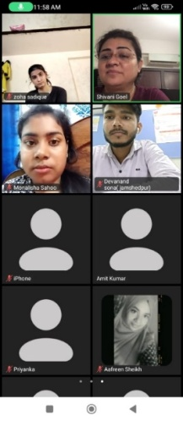
Event Photographs:

Outcomes:
- Mental Health Advocacy – Addressed critical issues like suicide prevention and stress management, reducing stigma through open dialogue.
- Youth Engagement – Reached 45+ students with life-saving awareness, empowering them to seek help or support peers.
- Skill Development – 4 members honed public speaking and critical thinking while advocating for mental health.
- Community Partnership – Collaboration with Jeevan Suicide Prevention Centre amplified the club’s social impact beyond Rotaract.
- Zero-Cost Impact – Delivered high-value awareness at ₹0 expense, proving advocacy need not be resource-intensive.
Words can save lives—and today, they did.

- Name of the event:Health Checkup Camp under District Project - आरोग्यम
Date and time: 31st August 2024
Mode of activity: In-person
Nature of activity: Community Services
Venue: Karim City College
Guest:N/A
Number of Participants: 2
Number of audiences: N/A
Announcement of activity:
Detailed Description: Rotaract Club of Karim City College organized a health checkup camp under the district project “आरोग्यम” for both teaching and non-teaching staff on August 31, 2024. A total of 22 staff members benefited from the camp.
Number of Beneficiaries:32 | Expenses Incurred: ₹500/-
Event Photographs:
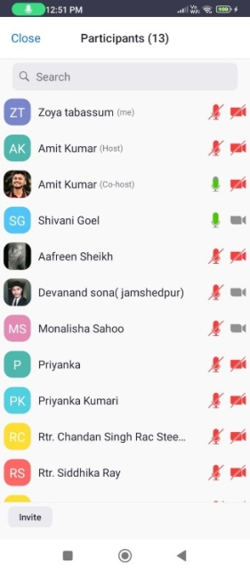
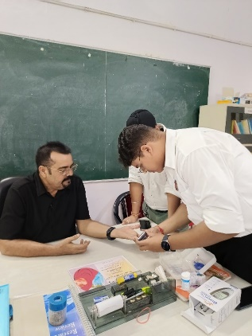
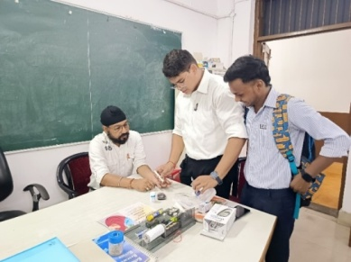

Outcomes:
- Holistic Health Screening – Provided 32 teaching/non-teaching staff with essential health checkups (e.g., BP, sugar levels, BMI), promoting preventive care.
- Workplace Wellness Culture – Encouraged staff to prioritize health, potentially reducing absenteeism and boosting productivity.
- District Impact – Advanced the "आरोग्यम" project’s goal of accessible healthcare, aligning with Rotaract District 3250’s priorities.
- High ROI Initiative – Maximized reach (32 beneficiaries) at minimal cost (₹500), demonstrating efficient budget utilization.
- Community Trust – Strengthened the club’s reputation as a proactive health ally within the college ecosystem.
Proof that big health impacts don’t need big budgets!

- Name of the event: ECOSWAP Phase 1: Rethinking Plastic (Webinar)
Date and time: 07th September 2024
Mode of activity: Online
Nature of activity: International Services
Venue: Google Meet
Guest: Amita Deshpande, Dr. Girija Bharat and Sandhya Sabapathy.
Number of Participants: 18 participants
Number of audiences: 53 audience
Announcement of activity: 05thAugust, 2024
Detailed Description: Rotaract Clubs of Karim City College and Delhi South East organized a webinar on September 7, 2024, to address plastic pollution. Over 90 participants attended, learning about the environmental impact of plastic and exploring sustainable alternatives. The project was a step towards promoting environmental sustainability.
Event Photographs:
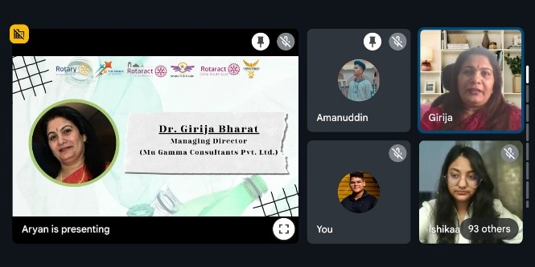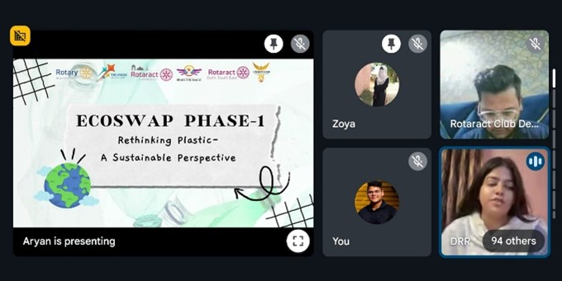

- Name of the event: Cervical Cancer Awareness and Vaccination Workshop
Date and time: 13th September 2024
Mode of activity: In person
Nature of activity: Community Services
Venue: Narbheram Hansraj English School
Guest: N/A
Number of Participants: 5 participants
Number of audiences: 318 audience
Announcement of activity: 07thSeptember, 2024
Detailed Description: Four members of the Rotaract Club of Karim City College actively participated in a cervical cancer awareness and vaccination workshop organized by the Rotary Club of Jamshedpur West at Narbheram Hansraj English School. The workshop aimed to educate women about the importance of cervical cancer prevention and provide access to the HPV vaccine. During the event, the Rotaract members assisted with registration, information dissemination, and providing support to participants. The workshop was a successful initiative in promoting women's health and preventing cervical cancer.
Event Photographs:
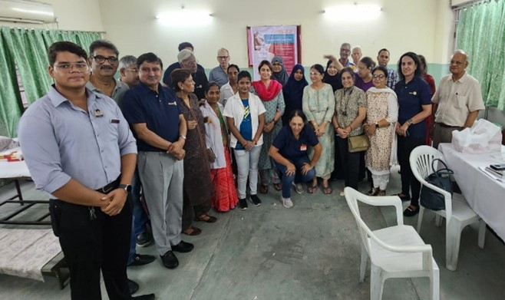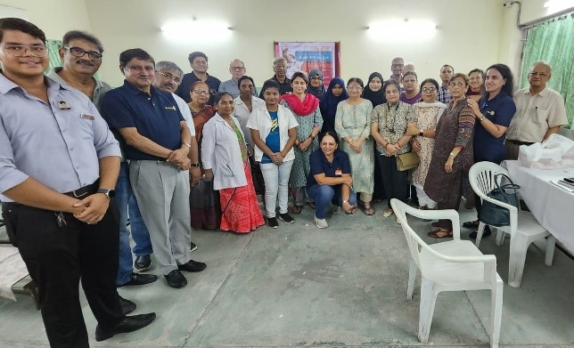

- Name of the event: Personal Branding (Webinar)
Date and time: 18th September 2024
Mode of activity: Online
Nature of activity: International Services
Venue: Google Meet
Guest:
Number of Participants: 15 participants
Number of audiences: 164 audience
Announcement of activity: 15thSeptember, 2024
Detailed Description: On September 18, 2024, the Rotaract Club of Karim City College and the Rotaract Club of Ashoka Artisans jointly organized a webinar focused on personal branding. The informative session was led by the esteemed speaker, Saijal Taparia.
During the webinar, participants gained valuable insights into the importance of personal branding in today's competitive world. The speaker provided practical tips and strategies on how to effectively build and manage a strong personal brand. The webinar concluded with a lively Q&A session, allowing participants to seek clarification and discuss their personal branding goals.
Event Photographs:
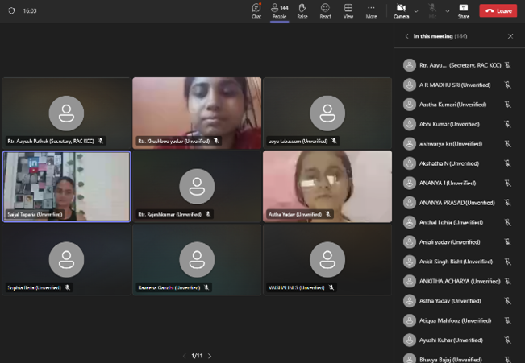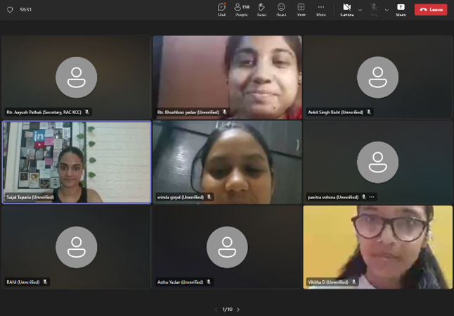

- Name of the event: Letterhead Exchange
Date and time: 23rd August 2024
Mode of activity: In person
Nature of activity: International Services
Venue: DRR House
Guest: DRR. RTR. Rinku Kumar and RTR. Aryan Verma
Number of Participants: 2 person
Number of audiences: 4 person
Announcement of activity: 21stAugust, 2024
Detailed Description: The Rotaract Club of Karim City College exchanged letterheads with the Rotaract Club of Muzaffarpur on September 23, 2024. This exchange serves as a symbol of collaboration and friendship between the two clubs, fostering potential future partnerships and initiatives.
Event Photographs:
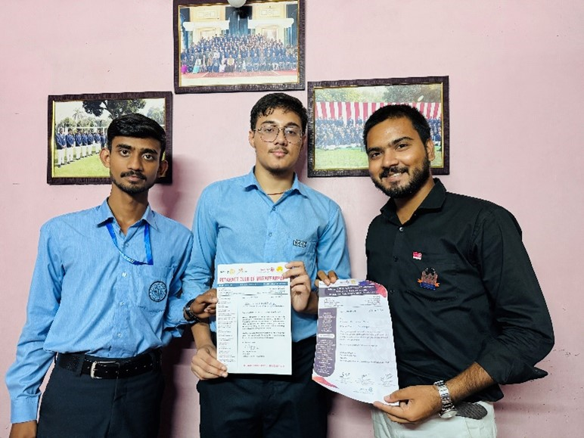

- Name of the event: Move for a Healthy Beat Challenge
Date and time: 30th September 2024
Mode of activity: In person
Nature of activity: Club Services
Venue: N/A
Guest: N/A
Number of Participants:
Number of audiences: 05
Announcement of activity: 05
Detailed Description: Rotaract Club of Karim City College actively participated in the "Move for the Beat Challenge" organized by the Rotary Club of Jamshedpur Steel City on September 30, 2024. Four enthusiastic members of the Rotaract Club joined the challenge and opted for the 5km walk activity. Their participation demonstrated their commitment to promoting health and fitness within the community.
Event Photographs:
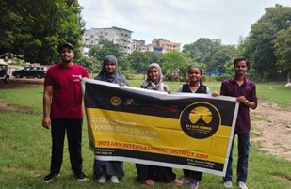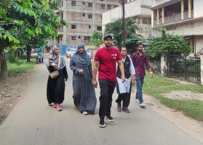

Name of the event: Visit to Old Age Home
Date and time: 01st October 2024
Mode of activity: in Person
Nature of activity: Community Services
Venue: Aashirwad Bhawan
Guest: N/A
Number of Participants: 11 participants
Number of audiences: 30+
Announcement of activity: 29thSeptember, 2024
Detailed Description: Rotaract Club of Karim City College organized a heartwarming visit to a local old age home on 1st October 2024. Club members spent quality time with the elderly residents, engaging in conversations, sharing laughter, and celebrating a member's birthday with a cake-cutting ceremony. This initiative aimed to bring joy, companionship, and a sense of community to the elderly residents. Over 30 beneficiaries were positively impacted by this project, which was executed with a budget of approximately 600 rupees.
Event Photographs:
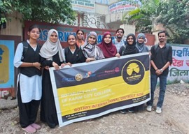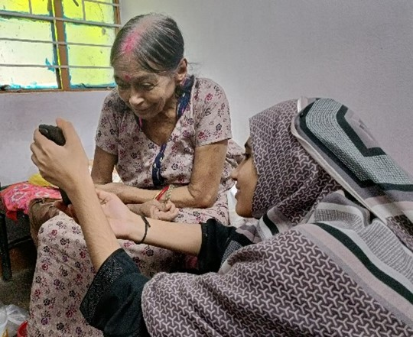

Name of the event: Sashakti 3.0
Date and time: 11th October 2024
Mode of activity: In person
Nature of activity: Community Services
Venue:
Guest:
Number of Participants: 04 participants
Number of audiences: 280+ person
Announcement of activity: 5thOctober, 2024
Detailed Description: The Rotaract Club of Karim City College partnered with the Rotaract Club of Steel City to organize Sashakti 3.0, a flagship event focused on empowering young girls. On 11th October 2024, the clubs celebrated Kanya Puja, honouring young girls through the distribution of 111 education kits containing essential school supplies. The event also included a bhogvitaran ceremony and the distribution of special gifts to the girls.
Event Photographs:
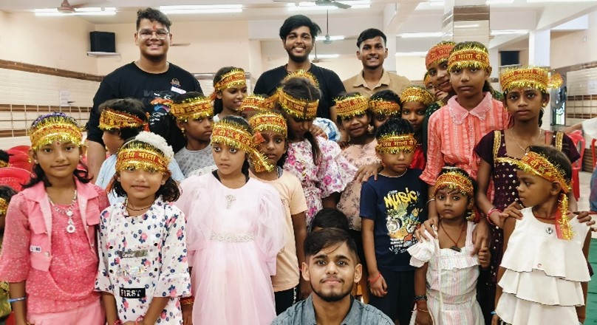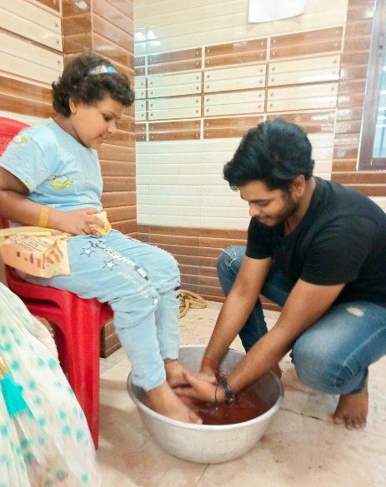

- Name of the event: Monthly Roti Day
Date and time: 14th October 2024
Mode of activity: In person
Nature of activity: Community Services
Venue:
Guest:
Number of Participants: 10 participants
Number of audiences: 37 people
Announcement of activity: 12thOctober, 2024
Detailed Description: The Rotaract Club of Karim City College continued its commitment to community service by organizing its monthly Roti Day on 14th October 2024. The club members prepared and distributed fresh rotis to 37 beneficiaries in need. This initiative was carried out at no additional cost.
Event Photographs:
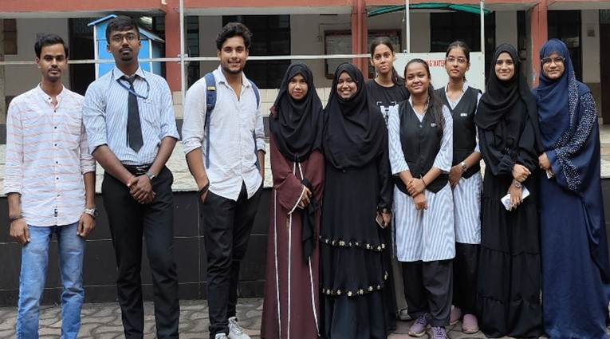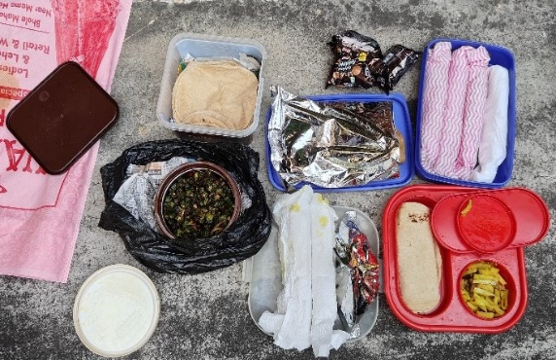

- Name of the event: Breast Cancer Awareness Programme
Date and time: 22nd October 2024
Mode of activity: In person
Nature of activity: Community Services
Venue: E- Classroom (KCC)
Guest: Rtn Dr. Sujata Mitra
Number of Participants: 8 participants
Number of audiences: 45+ people
Announcement of activity: 18thOctober, 2024
Detailed Description: Rotaract Club of Karim City College, in collaboration with the Women Cell of Karim City College, organized a comprehensive Breast Cancer Awareness Programme. The event featured a guest speaker, Rtn Dr. Sujata Mitra, who delivered an informative session on early detection, self-examinations, and preventive measures related to breast cancer. The interactive session addressed common concerns and dispelled myths surrounding the disease, empowering the attendees, primarily female students, with valuable knowledge.

Event Photographs:
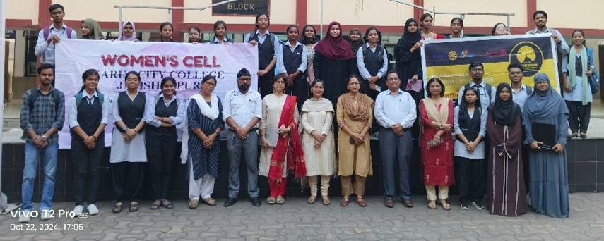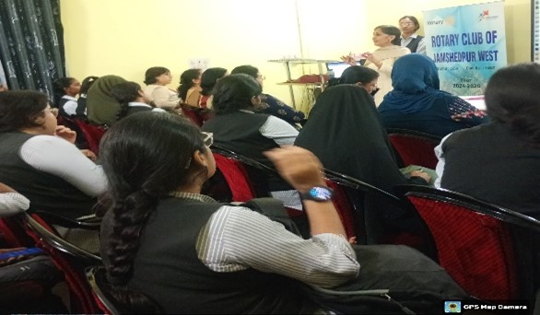

- Name of the event: Monthly Roti Day
Date and time: 14th November 2024
Mode of activity: In person
Nature of activity: Community Services
Venue: Near Shitla Mandir
Guest: N/A
Number of Participants: 6 participants
Number of audiences: 20+ people
Announcement of activity: 12thNovember, 2024
Detailed Description: Rotaract Club of Karim City College executed its monthly Roti Day on 14th November 2024. Members distributed roti rolls and other food items to 18 beneficiaries.
Event Photographs:
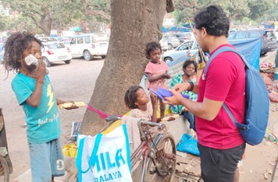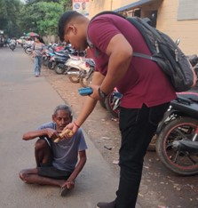

- Name of the event: Fellowship at Tata Zoological Park
Date and time: 16th November 2024
Mode of activity: In person
Nature of activity: Club Services
Venue: Tata Zoological Park
Guest: N/A
Number of Participants: 20 participants
Number of audiences: N/A
Announcement of activity: 12thNovember, 2024
Detailed Description: The Rotaract Club of Karim City College organized a fellowship event for its members at Tata Zoological Park on 16th November 2024. 20 Rotaractors participated in the event, spending time getting to know each other better and building camaraderie. The members enjoyed their time at the zoo, and the total expenses for the event were approximately Rs. 1200.
Event Photographs:
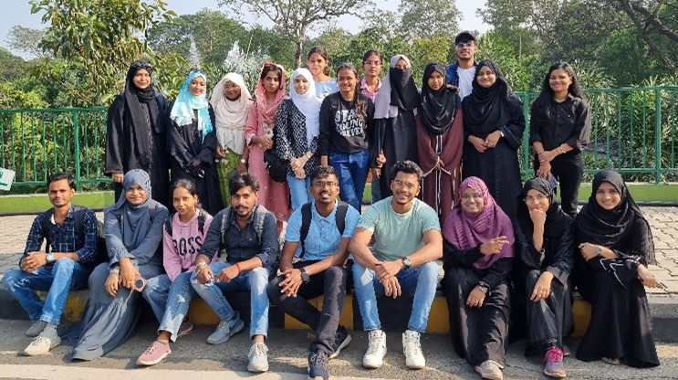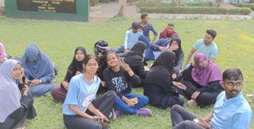

- Name of the event: आशीष - प्रकृतिकाआशीर्वाद (Tree Plantation Drive)
Date and time: 18th November 2024
Mode of activity: In person
Nature of activity: Community Services
Venue:
Guest:
Number of Participants: 5 participants
Number of audiences: 15 people
Announcement of activity:
Detailed Description: The Rotaract Club of Karim City College collaborated with the Rotaract Club of Arka Jain University (SCom) for their project "आशीष - प्रकृतिकाआशीर्वाद," a mega tree plantation drive. The club invited members from Arka Jain University to their college campus, where they planted a total of 11 trees.
Event Photographs:
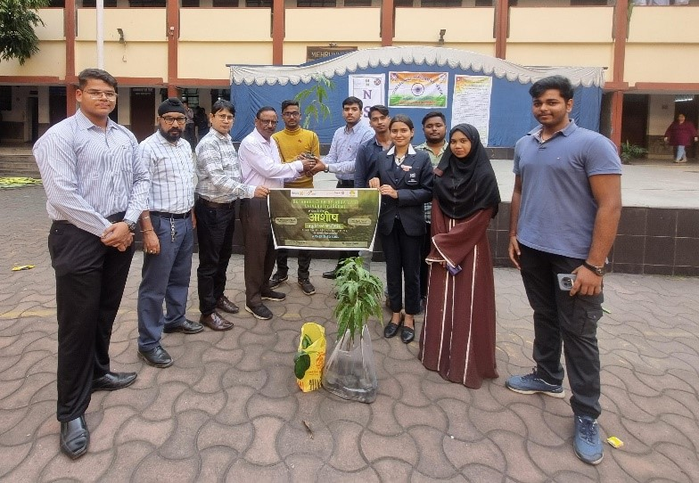

- Name of the event: Period Product & Sanitation Awareness
Date and time: 26th November 2024
Mode of activity: In person
Nature of activity: Community Services
Venue: Kabir Memorial English High School
Guest:
Number of Participants: 5 participants
Number of audiences: 75+ audiences
Announcement of activity: 20thNovember, 2024
Detailed Description: Rotaract Club of Karim City College, in collaboration with the Women's Cell of Karim City College, conducted a Period Product and Sanitation Awareness Drive. Members distributed sanitary napkins to over 50 students in classes 9 and 10 at Kabir Memorial English High School.
Event Photographs:
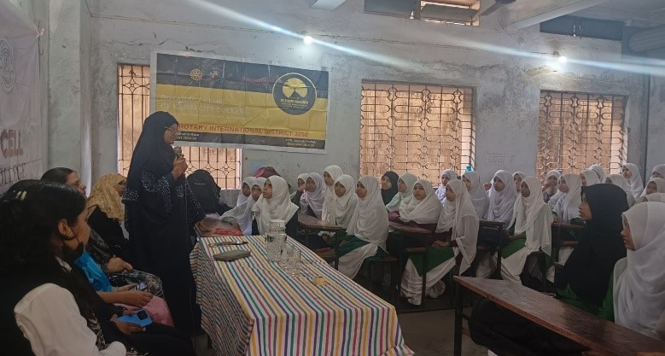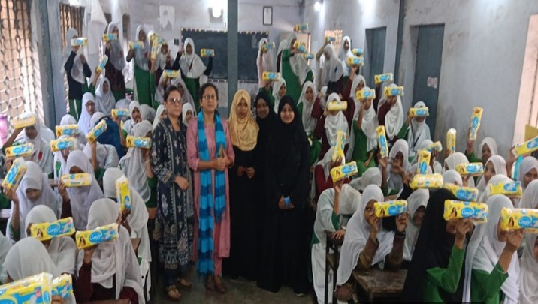

- Name of the event: Letterhead Exchange with Rotaract Club of Delhi Genesis Midwest
Date and time: 26th November 2024
Mode of activity: In person
Nature of activity: Club Services
Venue:
Guest:
Number of Participants:
Number of audiences:
Announcement of activity:
Detailed Description: Rotaract Club of Karim City College exchanged letterheads with the Rotaract Club of Delhi Genesis Midwest (RID 3011) on 26th November 2024, fostering inter-club relations and promoting collaboration
Event Photographs:
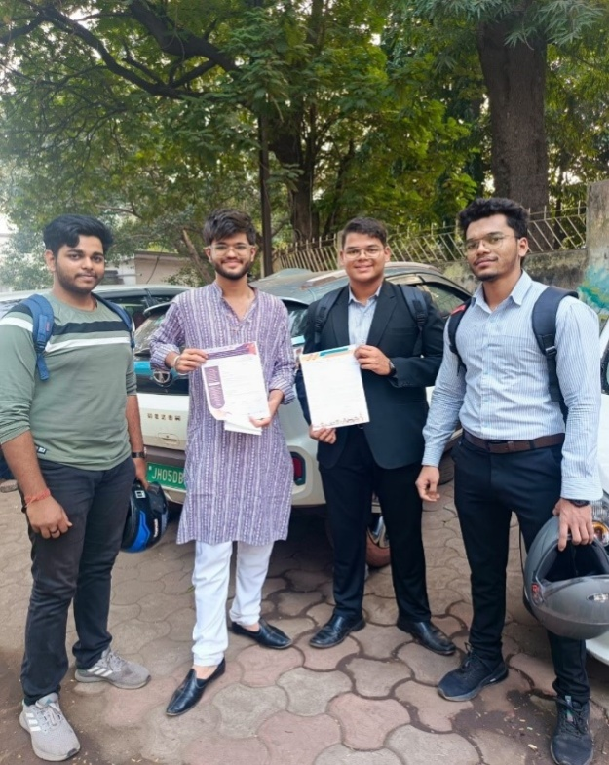

- Name of the event: Annual Roti Day
Date and time: 14thFebruary, 2025
Mode of activity: In person
Nature of activity: Community Services
Venue:
Guest:
Number of Participants: 20 participants
Number of audiences: 260+ people
Announcement of activity:
Detailed Description: On 14th February 2025, the Rotaract Club of Karim City College, successfully executed its annual Roti Day Project at Baradwari Basti, near Nirmal Hriday Missionary. The event was conducted in collaboration with two fellow Rotaract Clubs: Rotaract Club of KMPM Vocational College and Rotaract Club of Steel City. Together, we served 200+ beneficiaries with nutritious meals consisting of rice, sabzi, and sweets within a span of 2.5 hours.
Event Photographs:
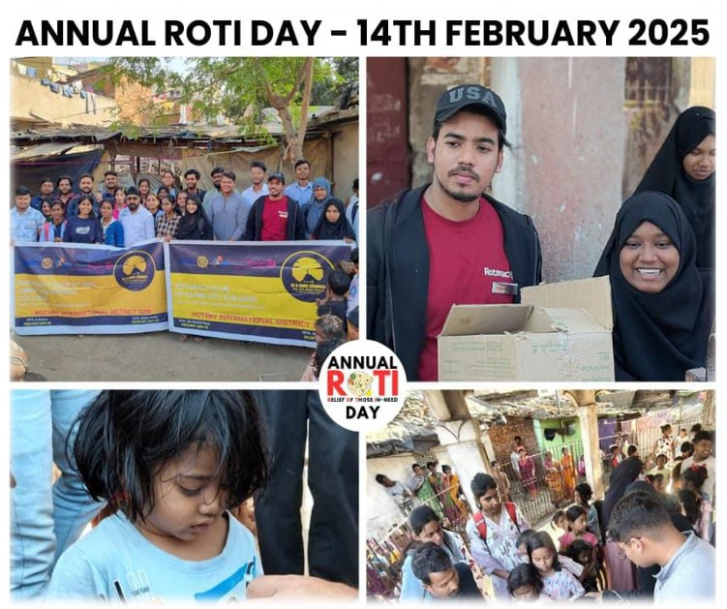

- Name of the event: JAMPEX 2025, a district-level philatelic exhibition.
Date and time: 22ndFebruary, 2025
Mode of activity: In person
Nature of activity: Club Services
Venue: Tulsi bhawan
Guest:1st Lady
Number of Participants: 15
Number of audiences: 90
Announcement of activity:
Detailed Description: :

Event Photographs:
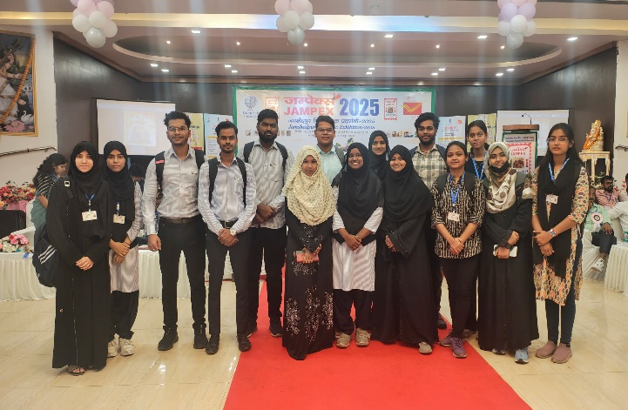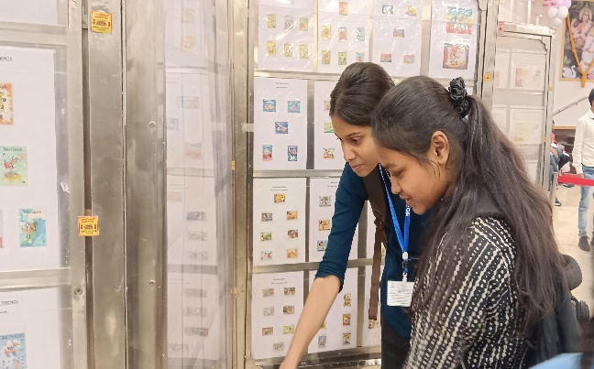

Name of the event: Cancare
Date and time: 22ndFebruary, 2025
Mode of activity: In person
Nature of activity: Community Services
Venue: Meherbai Tata Memorial Hospital
Guest:
Number of Participants: 15 participants
Number of audiences: 60+ people
Announcement of activity: 20thFebruary, 2025
Detailed Description: The Rotaract Club of Karim City College volunteered at the Cancare event , organized by the Rotary Club of Jamshedpur West at Meherbai Tata Memorial Hospital . The event celebrated Cancer Survivors Day, honoring their strength and resilience. Honoring Strength and Courage: Acknowledge the incredible strength and courage of cancer survivors.Celebrate their journey and the milestones they've achieved.
Event Photographs:
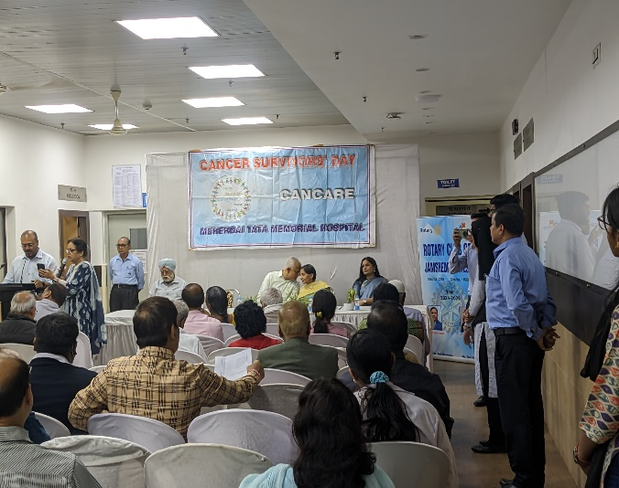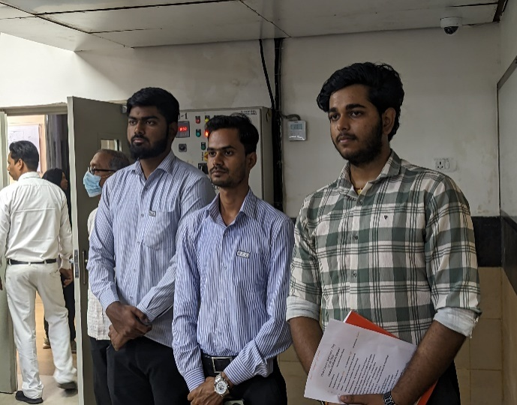

Name of the event: Old Age Home Visit
Date and time: 1stMarch, 2025
Mode of activity: In person
Nature of activity: Community Services
Venue: Aashirwad Bhawan
Guest: N/A
Number of Participants: 7 participants
Number of audiences: 30+ audiences
Announcement of activity: 27thFebruary, 2025
Detailed Description: Focusing on the impact of small gestures and time spent. Honoring the elderly and showing them the respect they deserve. 8 Rotaract students dedicated time to bring smiles to elderly residents.Providing valuable social interaction to reduce feelings of isolation.
Event Photographs:
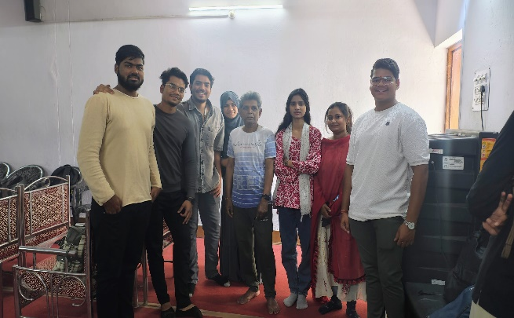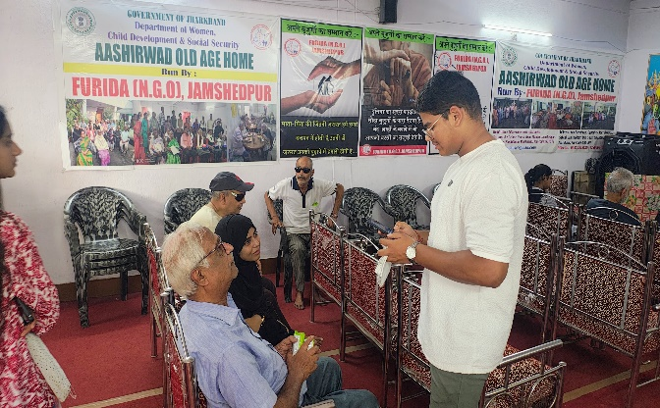

Name of the event: Food Distribution
Date and time: 2ndMarch, 2025
Mode of activity: In person
Nature of activity: Community Services
Venue: MGM Hospital, Sakchi
Guest: N/A
Number of Participants: 6 participants
Number of audiences: 100+ audiences
Announcement of activity: 27thFebruary, 2025
Detailed Description: Rotaract Club of Karim City College helped in the food distribution being held in the MGM Hospital. The food drive raises awareness about the importance of food security and the needs of hospital patients.The involvement of the Rotaract Club encourages student volunteerism and instills a sense of social responsibility.Our support was acknowledged as 6 dozens of bananas and 8 family pack of bread loafs were provided for distribution.
Event Photographs:

Name of the event: Mahadaan 10.0
Date and time: 21stMarch, 2025
Mode of activity: In Person
Nature of activity: Community Services
Venue: Jamshedpur Blood Bank
Guest: DRR. RTR. Rinku Kumar
Number of Participants: 5 participants
Number of audiences: 20
Announcement of activity: 17thMarch, 2025
Detailed Description: The "Mahadaan 10.0" blood donation camp, organized by the Rotaract Club of Karim City College, was a resounding success! The unwavering dedication and active participation of our club members were instrumental in the event's smooth execution and positive impact. This event truly reflected our club's deep commitment to social responsibility and community service.
The Rotaract Club of Karim City College extends its heartfelt gratitude to the Jamshedpur Blood Bank for their invaluable cooperation and to all the generous individuals who donated blood.
Event Photographs:
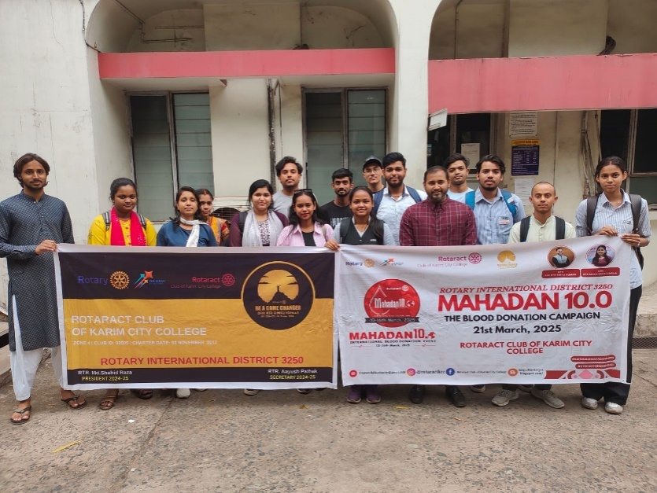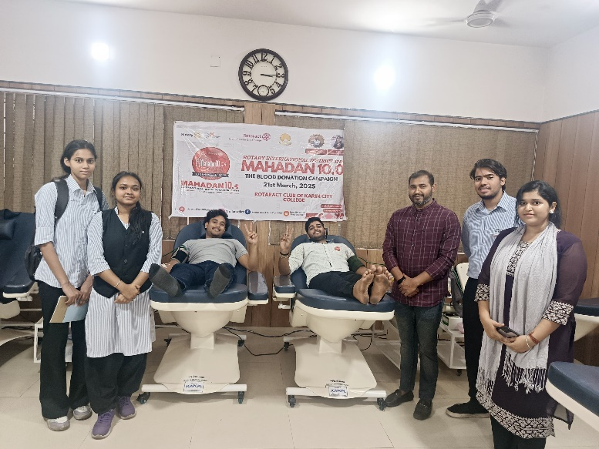

News Clippings:
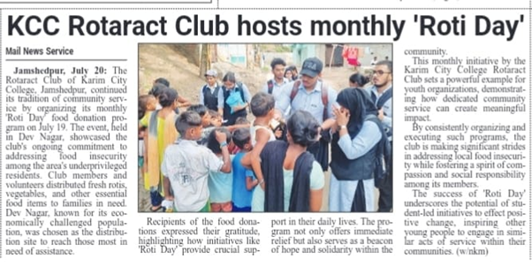
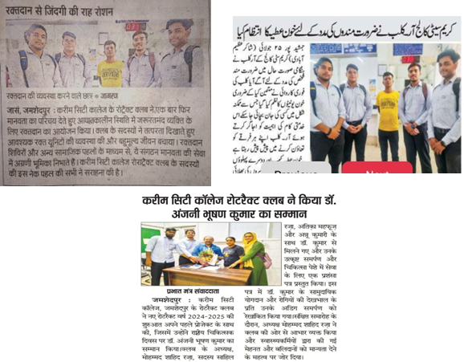

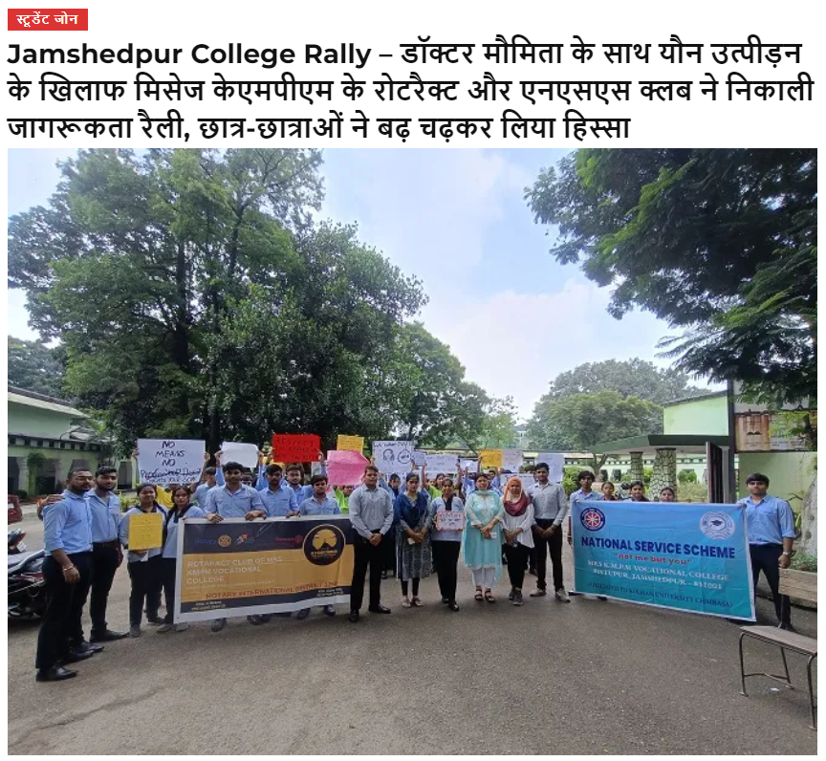
Name and signature of moderator: Dr. Udham Singh

