**KARIM CITY COLLEGE, JAMSHEDPUR**

ACTIVITIES 2024-25

**Centre for Guidance & Counselling**

**Name of The Activity / Event : -** Skill and Personality Development Programme

**Date & Time : -** 18-12-2024

**Mode of the Activity / Event : -** In - Person

**Nature of the Events : -**  Academic

**Venue : -** Karim City College (Mango Campus)

**Chief Guest & Other Guests : -** Dr. SK Anwar Ali(In-Charge, Mango Campus)

**Numbers of Participants / Performers : -** 80

**Approx Number of Audience : -** 120

**Announcement of the Activity / Event : -**

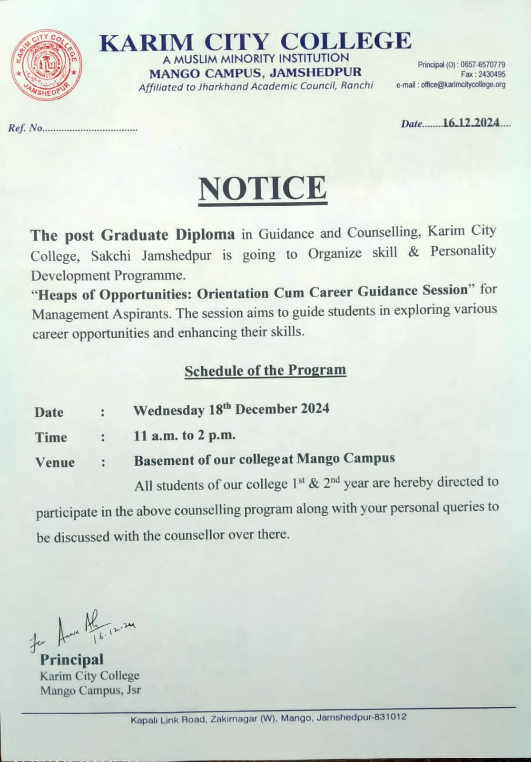

**Detailed Description : -**

The Skill and Personality Development Programme was organized by the Centre for Guidance and Counselling at Karim City College to assess the level of stress and mental health and Career Opportunities for Intermediate students. The initiative aimed to provide psychological support, identify key stressors, and offer coping strategies to enhance students' well-being.

**Event Photographs : -**

|  |
| --- |
|  |

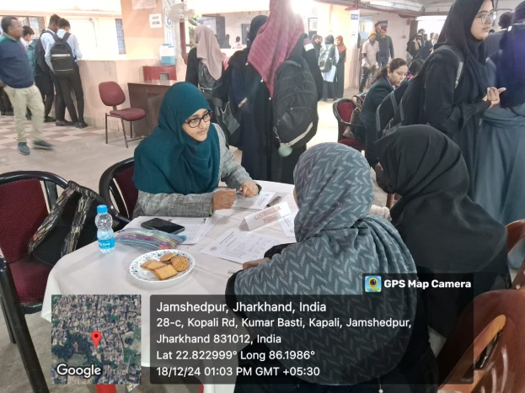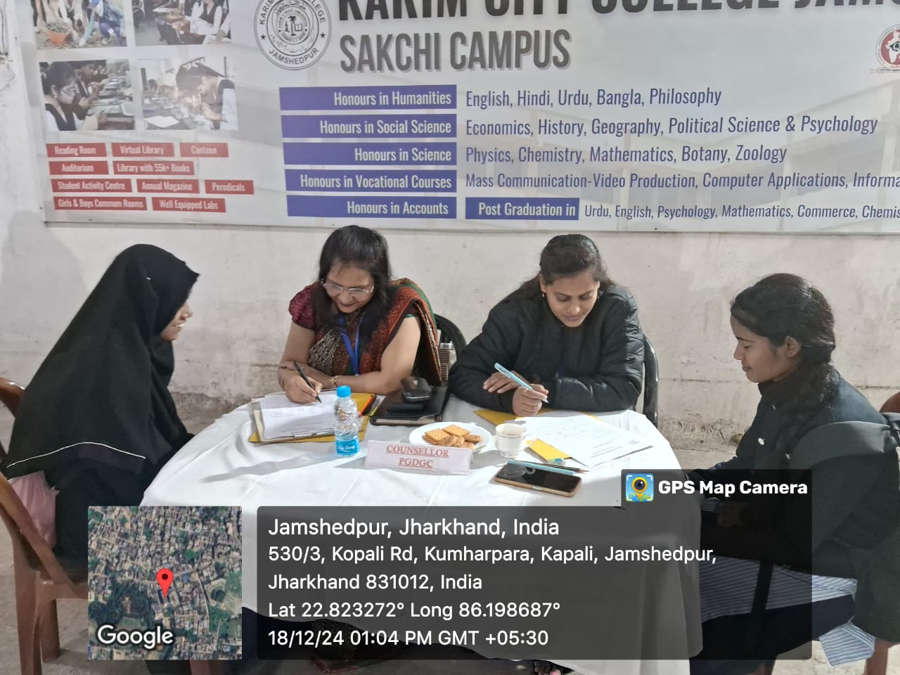

**News Clippings : -**

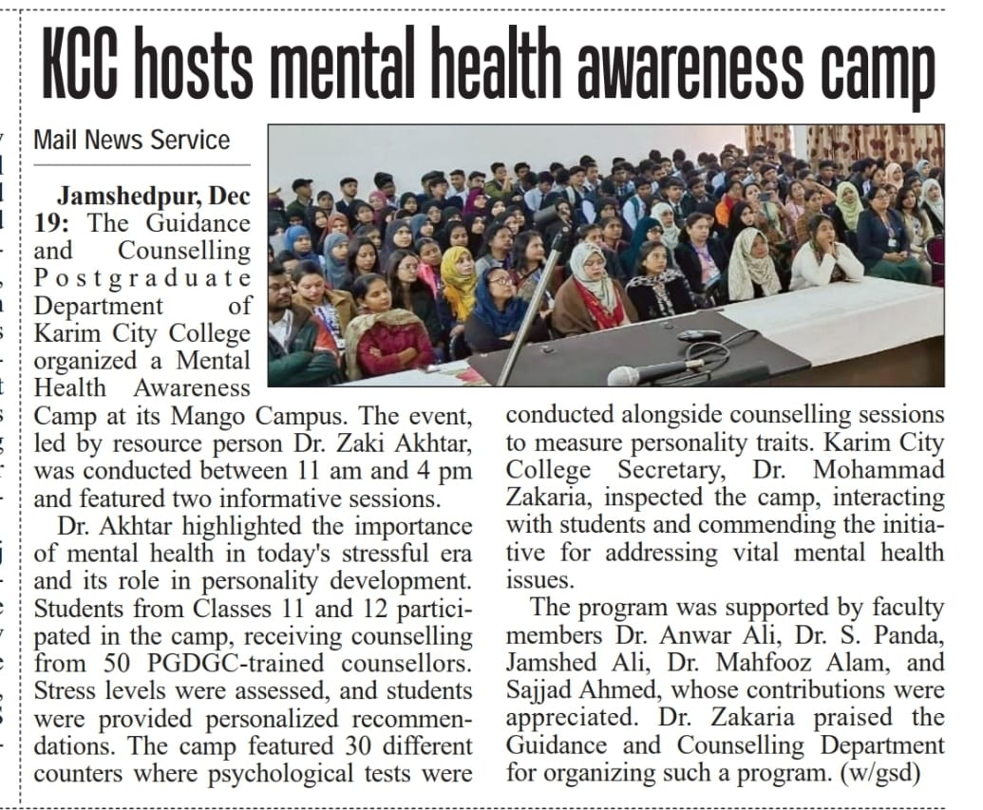

**Outcomes : -**

The Skill and Personality Development Programme was organized by the Centre for Guidance and Counselling at Karim City College to assess the level of stress and mental health and Career Opportunities for Intermediate students. The initiative aimed to provide psychological support, identify key stressors, and offer coping strategies to enhance students' well-being.

Following are the outcomes:

1. Coping Strategies – Practical techniques such as mindfulness, time management, and relaxation exercises were introduced to help students manage stress effectively.

2. Referral for Further Support – Students requiring extended psychological support were guided toward professional counselling and intervention.

3. Positive Student Feedback – Participants appreciated the initiative, reporting a better understanding of their mental health and a more confident approach to handling stress.

Identification of Stress Factors – Common academic, personal, and social stressors affecting students were identified.

4. Mental Health Awareness – Students gained insights into the importance of mental well-being and the impact of stress on their daily lives.

5. Personalized Counselling – Many students received one-on-one counselling sessions to discuss their concerns and challenges.